17th North America-Europe Data Exchange Meeting

Canadian Meteorological Centre, Dorval, Canada
26-28 May 2004

Final report dated 28 June 2004
Contents

1. Introduction 2
2. European Requirements 2
3. North American Requirements 18
4. Table of Meteorological Service of Canada Data Requirements 32
5. Status of actions from 16th Meeting 35
5.1 Actions related to North American requirements 35
5.2 Actions related to European requirements 36
5.3 Miscellaneous Actions 38
6. Actions from 17th Meeting 40
6.1 Actions related to European requirements 40
6.2 Actions related to North American requirements 42
6.3 Miscellaneous Actions 43
6.4 Points for information 45
7. Conclusions 46
ATTACHMENT-I: Agenda 47
ATTACHMENT-II: List of participants 48
ATTACHMENT-III: Terms of reference of the NA/Europe Data Exchange Forum 49
ATTACHMENT-IV: NOAA/NESDIS Status Report (G. Legg) 51
ATTACHMENT-V: NCEP Status Report (S. Lord) 52
ATTACHMENT-VI: Status report from the Meteorological Service of Canada (G. Verner) 53
ATTACHMENT-VII: EUMETSAT Status Report (K. Holmlund) 60
ATTACHMENT-VIII: ECMWF Status Report (H. Böttger/J.-N. Thépaut) 65
ATTACHMENT-IX: METO Status Report (R. Saunders) 66
ATTACHMENT-X: M-F status report (B. Lacroix /H. Roquet) 72
ATTACHMENT-XI: DWD Status Report (R. Hess) 76
ATTACHMENT-XII: TOC Telecommunications Status Report (F. Branski) 77
ATTACHMENT-XII-I: International Satellite Communication System (ISCS) 77
ATTACHMENT-XII-II: NWS Web Bulletin Input Form Guidance Documentation 85
ATTACHMENT-XII-III: NWS EMWIN System 89
ATTACHMENT-XII-IV: NWS eMail Data Input System (EDIS) 92
ATTACHMENT-XIII: METO Telecommunications Status Report (D. Hennings) 95
ATTACHMENT-XIV: Priorities on the Washington-Exeter link 113

1. Introduction
The meeting was chaired by Jean-Guy Desmarais, Director of the Development Branch at the Canadian Meteorological Centre in Dorval, Canada. On behalf of the Meteorological Service of Canada, he opened the 17th meeting by welcoming the group to Montréal and to the CMC. He reminded the importance of the work of this group as a forum to refine the data requirements of the NWP centres and to consider the means of getting data from the data providers to the NWP community. He also noted that this was the fifth participation of the CMC at this meeting and that this participation has proven to be very beneficial to the MSC and the CMC. He also reflected on the major challenges we will be facing over the upcoming years, in relation to the exploding volumes of satellite data that will be made available, and the difficulties this will present for telecommunications, data storage and data processing systems. Referring to the agenda (attachment I) he emphasised that the main work of the group was on the second day when we will review and discuss the requirements of both Europe and North America. Finally, he informed the group that two of the participants (Emilie Bruchon and Gene Legg) could not make it to the meeting and he presented their regrets to the group. However, we were able to connect Gene by telephone, and Gene was therefore able to make his presentations and to actively participate in the discussions. The list of participants is given in attachment II.
This report consists of the detailed European and North American requirements documents tabled at this meeting in sections 2 and 3. The Canadian requirements are all common to the European and North American lists and so a table is provided in section 4 referring to the corresponding items in sections 2 and 3. The review of actions from the 16th meeting is given in section 5 and the list of actions formulated during this meeting (including those carried-over for the list of the 16th meeting) is in section 6. The status reports from the satellite agencies, NWP centres and telecommunication groups which were provided by the presenters are included as attachments to this report. There are also PowerPoint presentation files available from Gilles Verner (Gilles.Verner@ec.gc.ca) (or from the CD ROM) for some of the status reports as indicated in the heading for each report. There are also several other attachments provided in response to actions from the previous meetings.

2. European Requirements
This section presents the combined status of and requirements for data and products from NOAA and MSC for operational NWP and related activities in Europe. Unless otherwise specified, the stated requirement represents a common requirement of two or more centres.
A key requirement common to all the products listed below is the reliable exchange of information on any changes impacting any of the transmitted products. Timely exchange of information will help in explaining anomalies in the monitoring and if assimilated in forecast trends.

The European Met. Services referred to in this document together with the abbreviations used are:

DMI: Danish Meteorological Institute
DNMI: Norwegian Meteorological Institute
DWD: German Weather Service
KNMI: Royal Netherlands Meteorological Institute
ECMWF: European Centre for Medium Range Weather Forecasting
EUMETSAT: European Organisation for the Exploitation of Meteorological Satellites
METEO-FRANCE: Météo-France
METO: Met Office (U.K.)

E.1. POLAR SATELLITES: ORBIT-BY-ORBIT DATA/PRODUCTS
E.1.1 TOVS
E.

1.1.1 500 km TOVS SATEMs (retrievals only)
Status: All centres stopped using the data.
Comments:

Requirement: No.

E.1.1.2 Level 1B TOVS data
Status: Data routinely copied from NESDIS via dedicated link to METO. Data passed to ECMWF who encode the 1B data into BUFR. Access given to other European Met. Services.
Comments: ECMWF: TOVS 1B radiances from NOAA-14 are monitored (as backup and for independent validation). SSU from NOAA-14 are received and monitored.

Requirement: Yes.

E.1.2 ATOVS
E.1.2.1 ATOVS 120km retrievals and clear radiances in BUFR
Status: Available on GTS.
Comments: DWD: Assimilated operationally, to be replaced with 1D-Var retrievals in 2004, until summer 2005 verification of 1D-Var retrievals.

Requirement: Yes by DWD.

E.1.2.2 ATOVS level 1B data
Status: Data copied from NESDIS via dedicated link to METO who encode the 1B data into BUFR(1C data). Access given to other European Met. Services and ECMWF. There is a continuing requirement to receive AMSU data in 1B rather than 1C form as the AMSU housekeeping information is monitored by METO.

Comments: METO: NOAA-15 AMSU-A/B, NOAA-16 HIRS/AMSU-A/B assimilated and monitored routinely. Plots available on the Met Office www site at: (http://www.metoffice.com/research/interproj/nwpsaf/monitoring.html).
Occasional days when data > 7hours old which misses model update runs. Would like to see the timeliness improved. All centres have an interest in receiving the full blind orbit data earlier and in time for use in data assimilation.
ECMWF: 1C radiances from NOAA-15 16 and 17 assimilated operationally (AMSUA from 15 and 16 and HIRS/AMSUB from 16 and 17). Monitoring statistics can be found in http://www.ecmwf.int/products/forecasts/d/charts/monitoring/satellite
METEO-FRANCE: 1C radiances (AMSU-A from NOAA-15 and 16 and HIRS from NOAA-16 and 17) assimilated operationally.
DWD: Data monitored. Operational use (AMSU A from NOAA-15 and 16) in 1D-Var will start in 2004.
Requirement: Yes.

E.1.2.3 ATOVS and AVHRR level-0 raw HRPT data from NOAA/NESDIS
Status: Not received.
Comments: ATOVS derived products with strict timeliness requirement (<30 minutes after start of pass) have been provided since 12 November 2002 with the EUMETSAT ATOVS Retransmission Service (EARS). Planned usage is for short-range NWP in Europe. The approach for transmitting the data to Europe is via a dedicated IP Virtual Private Network. The current service provides ATOVS derived products from Kangerlussuaq (Greenland), Tromsø (Norway) and Maspalomas (Canary Islands). The next station planned for integration is Athens (Greece). A co-operation agreement has been signed with NOAA enabling the integration of further stations in North America (Monterey, Wallops, Gilmore Creek) and the provision of data to the US has been signed. Negotiations with Canada are on-going.
ECMWF/METEO-FRANCE/DWD: Plan to use these data to fill in the missing 'late' orbits from NESDIS to allow use for NWP. Only Tromsø, Maspalomas and Kangerlussuaq received at present.
METO: About to assimilate EARS AMSU-A/B radiances in regional and global NWP models to fill in gaps due to late NESDIS ATOVS data.
DWD: Plans to use these data in the regional model (LM).
Requirement: Yes.

E.1.2.4 AVHRR products on HIRS grid, derived as part of NESDIS ATOVS processing
Status: NOAA-16/17 data now copied via dedicated link to METO.
Comments: METO: Plan to use these data to assist the HIRS cloud clearing but low priority at present. Recent problem with AVHRR fractional cloud cover being worked on with NESDIS. Contact is frank.tilly@noaa.gov.
ECMWF/DWD: Plan to use these data from NOAA-16 and 17 to assist the HIRS cloud detection.
METEO-FRANCE: Plans to use data from NOAA-16 and 17 to assist the HIRS cloud detection.
Requirement: Yes.

E.1.3 Ozone retrieved profiles and/or total column from SBUV on NOAA
Status: BUFR dataset copied via dedicated link from NESDIS to Bracknell and ECMWF. Point of contact established with J. Smith, NESDIS (johnny.smith@noaa.gov). New BUFR template for ozone defined by ECMWF and is being considered by WMO for approval.
Comments: ECMWF: Assimilate these data operationally from NOAA-16. Monitor these data from NOAA-17 (plans for operational assim.)
METO: We are receiving and archiving NOAA-16/17 SBUV data via ECMWF so that we can use the data in their BUFR format. Interested to assimilate for future improvements to stratospheric analysis. Current NESDIS files do not conform to standard BUFR conventions.
DWD: Validation of stratospheric ozone model forecasts.
METEO-FRANCE: Validation of chemical transport model.
EUMETSAT: The use of total column for the validation of the Total Ozone Product from MSG data will be investigated. Data would be received via ECMWF.
Requirement: Yes.

E.1.4 SeaWinds Scatterometer Data
Status: QuikScat launched in May 1999. Gene.Legg@noaa.gov is NESDIS contact The NESDIS to Bracknell link was upgraded to carry the SeaWinds data.
Comments: QuikSCAT data received, monitored and assimilated. Request information on future funding for QuikSCAT now ADEOS-2 has failed.
ECMWF: Assimilated operationally since 22 January 2002.
METO: Assimilated operationally since 10 Dec 2002.
METEO-FRANCE: For usage in marine forecast (visualisation by forecasters, input to wave model) and will perform impact studies in NWP.
DWD: Intend to assimilate operationally. After operational usage also interest in other Scatterometer Data (ERS2). Usage in marine forecasts envisaged.
KNMI: Reprocessing Quikscat as part of the OSI SAF.
DNMI also have expressed an interest in these data.
Requirement: Yes, in real-time.

E.1.5 SSM/I and SSM/IS on DMSP satellite
E.1.5.1 SSM/I brightness temperatures
Status: F-13, F-14 and F-15 data received from NESDIS server. Data passed to ECMWF where they are BUFR-encoded and returned to METO for onward transmission to other European centres. Fully operational service requires BUFR encoding at NESDIS.
Comments: ECMWF: Data from the three satellites are received and assimilated directly in radiance space.
METO: Monitored routinely and processed via a 1D-Var scheme to retrieve total column water vapour (TCWV), sea-surface wind speed and cloud liquid water. Operational assimilation of F-13 and F-15 wind speed. Assimilation of TCWV still being tested.
METEO-FRANCE: F13 and F15 are received at Toulouse. Used to retrieve products for forecasters: sea ice, rain rate, wind speed, total column water vapour and snow. Plans test impact of radiances.
EUMETSAT: It is planned to use SSM/I derived rain rates for calibration of an NRT rain rate product from METEOSAT.
DWD: Data are received from METO, plans for monitoring with view towards operational usage.
Requirement: Yes

E.1.5.2 SSM/I retrieved products (surface wind speed (WS), total column water vapour (TCWV), cloud liquid water (CLW), rain rate, others?)
Status: Available on NESDIS server to be copied via Internet
Comments: METO: Currently using 1.5.1 to derive the products.
ECMWF: assimilate directly radiances. These product files are primarily useful for comparison. Any updated information on the status of these products and the algorithms is requested.
METEO-FRANCE: Currently using 1.5.1 to derive the products.
DWD: Surface wind speed products for verification and research.

Requirement: Yes

E.1.5.3 SSM/IS
Status: Launch October 2003
Comments: ECMWF: Envisage radiance assimilation of SSM/IS similar to AMSU and SSM/I. Eager to receive first SSM/IS samples for technical validation.
METO: The SSMI(S) BUFR format has been defined with USN. Negotiations still underway with FNMOC as to when the initial data will be released to NWP centres. Radiances similar to AMSU and SSM/I will be used.
METEO-FRANCE: Plans to monitor and eventually use in assimilation.
DWD: Plans to monitor with a view towards assimilation.
Requirement: Yes

E.1.5.4 OLS visible and thermal data
Status: Not received.
Comments: DMI, Ice Charting and Remote Sensing Division, requests OLS visible and thermal data DMSP covering the whole or part of the waters around Greenland at a .5 km pixel resolution. In principle, DMI would like to get images from all waters around Greenland, but could identify a few high priority areas. DMI is interested in getting OLS visible and thermal data.
Requirement: Yes at DMI.

E.1.6 Altimeter data (TOPEX/POSEIDON/JASON)
E.1.6.1 Altimeter wave/wind data
Status: MetO has access to JASON via Internet for research. JASON data are put on GTS by METEO-FRANCE, as bulletin in BUFR format.
Comments: ECMWF: Data are routinely monitored. Assimilation trial experiments are underway.
METO: Altimeter wave heights AND wind speeds required with timeliness of < 3 hours. We do not receive any TOPEX/Poseidon real time data but have access to JASON data.
DWD: Intention to use the data (wave heights and wind speed) for verification and later on in a wave model (timeliness of <3 hours).
METEO-FRANCE: Required for wave model.
Requirement: Yes.

E.1.6.2 Altimeter sea surface height data
Status: Not received in near real-time. Delayed mode data received via CLS(?) (Toulouse).
NASA is expected to produce the data using a similar processing chain. Information is requested about the planned provision of the data via the GTS. BUFR formats have recently been defined.
Comments: ECMWF: The CLS(?) products, based on ERS and TOPEX/POSEIDON data, are used regularly. Fast-delivery altimeter data are also required.
METO: Receive near real-time DUACS data products twice a week and use them in the operational FOAM suite.
Requirements: Yes

E.1.7 TERRA and AQUA data (previously EOS)
E.1.7.1 AQUA AIRS+AMSU-A+HSB data
Status: Launched by NASA in May 2002. NESDIS process data in near-real time and transfer them in BUFR to METO. European centres in regular contact with M. Goldberg and W. Wolf (NESDIS) for technical and scientific evaluation.
Comments: ECMWF: Perform test assimilation experiments since October 2002. Assimilate AIRS and AMSU-A operationally since October 2003. Monitoring available at: http://www.ecmwf.int/products/forecasts/d/charts/monitoring/satellite. Interest for NRT access to mapped VIS products, and also to mapped MODIS cloud products.
METO: Received data since 11 Oct 2002. AIRS monitoring web page at:
http://www.metoffice.com/research/nwp/satellite/infrared/sounders/
The userid is airspage and password &Graces
Assimilation trials completed. Operational use from June 04.
DWD: The minimum requirement is for a sampled set of AIRS radiances within 3 hours of measurement + separate AMSU-A and HSB full resolution datasets. Strong interest in monitoring these data and in their operational use.
METEO-FRANCE: Strong interest in monitoring these data and in their operational use. Technical developments and initial tests performed; extensive testing starting.
Requirement: Yes, in near real-time.

E.1.7.2 MODIS clear-sky radiance data
Status: Launched on TERRA-1 in Dec. 1999 and on AQUA in May 2002.
Comments: ECMWF: A near-real time 50km cloud cleared radiance dataset for the infrared temperature and water vapour sounding channels would be of interest for monitoring and possible operational assimilation (at ECMWF). A sample dataset has been provided by CIMSS and will be evaluated. Please update status of any plans for a real-time MODIS product. These data also of interest for cloud detection for AIRS on AQUA.
METEO-FRANCE: Interest for research.
Requirement: Yes, in near real-time.

E.1.7.3 AMSR data
Status: AMSR-E on Aqua. Real time data availability now via Walter Wolf.
Comments: ECMWF is developing a new capability for assimilating rain-affected radiances. Interest for these data as a complement to TRMM and SSM/I.
METO plan to use these data for assimilation of inferred precipitation information.
METEO-FRANCE: Interest in particular for soil moisture analysis.
Requirement: Yes, in near real time.

E.1.7.4 MODIS polar winds
Status: University of Wisconsin and more recently NESDIS produce cloud track winds from MODIS-Terra/Aqua over polar regions.
Comments: ECMWF assimilates the data operationally, via ftp access from CIMSS. Strong interest for an operational product (via NESDIS). Products from AQUA are now available and are being evaluated. NESDIS products for both AQUA and TERRA are of much better quality. Interest to move towards using these products once the timeliness issue is resolved.
METO is planning to assimilate NESDIS winds in late 2004.
DWD: Assimilation of CIMSS data since December 2003. Comparison with NESDIS data underway.
METEO-FRANCE: Interest of an operational product for assimilation. Required.
Requirement: Yes, in near real time, from both AQUA and TERRA.

E.1.7.5 AURA: HIRDLS, MLS, OMI and TES
Status: Expected launch in Summer 2004. Will provide precious information on various chemical constituents of the atmosphere
Comments: ECMWF/METO: Interested in accessing the products for monitoring and possible ozone operational assimilation. Would like information on how data and products will be made available to the users.
Requirement: Yes, in near real-time, if feasible.

E.1.8 Windsat/CORIOLIS
Status: Launched in Dec 2002
Comments: ECMWF: No information available on if and when data become available. Maybe too late for a real interest in near real time (short mission). Will follow developments at the MetOffice and concentrate on operational CMIS at a later stage. Interest for validation.
METO: Sample data received in Nov 2003 for evaluation as member of science team. Larger dataset offered. Real time data access is still not clear.
Requirement: Yes, in real-time.

E.1.9 COSMIC Radio-Occultation constellation
Status: UCAR data will be available in BUFR in real time. Contact is kuo@ucar.edu
Comments: Request for data to be made available via NESDIS for operational use.
METO: interested to receive samples of CHAMP, SAC-C and GRACE data to demonstrate capability.
ECMWF: Is experimenting RO data assimilation with CHAMP data sets. Interested to access COSMIC as soon as possible after launch.

E.2. POLAR SATELLITES: MAPPED PRODUCTS (not orbit-by-orbit)
E.2.1 SSM/I Products
E.2.1.1 Ice/snow gridded field derived from SSM/I data
Status: Received routinely via Washington-Bracknell link. Contact point J. Tesmer (tesmerj@fnoc.navy.mil).
Comments: ECMWF: Recently moved from 2.1.1 to 2.1.2. Interest for verification.
Requirement: Yes.

E.2.1.2 NCEP sea-ice analysis
Status: Data received routinely via Washington-Bracknell link.
Comments: METO: Used operationally in global NWP model, copied on Internet from NCEP server.
ECMWF: Used operationally.
DWD: Used operationally.
METEO-FRANCE: Interest for verification.
Requirement: Yes.

E.2.2 AVHRR
E.2.2.1 AVHRR SST retrievals as SATOBs
Status: Data used operationally at METO within SST analysis. In addition to SATOBs, 100km and 50km AVHRR SSTs are being received from NESDIS via operational link. Contact John Sapper (john.sapper@noaa.gov)
Comments: METO: About to start using the 100/50km product operationally for assimilation in UK models to replace SATOB.
METEO-FRANCE: Interest for research in SST analysis.
Requirement: Yes at METO and METEO-FRANCE. METO requirement for 100/50km SSTs will become the primary one from mid 2004.

E.2.2.2 AVHRR/MODIS products (eg vegetation indices, LAI, land use)
Status: Products available from internet or order from EOS data gateway.
Comments: ECMWF: Potential interest in these datasets in the future (especially in the context of environmental monitoring). Information on availability of these products requested and NESDIS point of contact. Research requirement for monthly datasets of aerosol optical depth for model validation. Also interested in previous years if available.

METO: MODIS products required are: (i) Monthly updated fractional land cover product at 1 km resolution and global coverage, (ii) Weekly updated Leaf Area Index at 1 km resolution and global coverage. Qualified subscription service for local area data now available and products extracted.
METEO-FRANCE: Interest for verification.
Requirement: Access to datasets via NASA server or QSS.

E.2.3 Mapped AVHRR imagery
Status: Daily or sometimes twice daily composites received by METO. Contact point joseph.askew@noaa.gov.
Comments: METO: Requirement is for 12 hourly AVHRR GAC composites from NESDIS for forecasters for global cloud cover. Images on the NESDIS web site are now the primary data source but dataset on dedicated link still required for backup. Still working with NESDIS to include overpass times on composite images.
METEO-FRANCE: Interest to complement global geo-stationary satellite imagery.
Requirement: Yes.

E.3. GEOSTATIONARY SATELLITES: DATA/PRODUCTS
E.3.1 GOES cloud-tracked VIS/IR/WV winds
Status: High density (HD) product on GTS in BUFR and SATOB.
Comment: ECMWF: The HD winds are used operationally thinned to one wind per 1.25 deg box. GOES BUFR data received via GTS are now used operationally.
METO: SATOB product obtained via FTP not GTS on dedicated link. HD IR winds are used operationally and thinned to one wind per 2x2 deg box. Evaluated new BUFR product and happy with it. Will use operationally from late 2004.
DWD: Used operationally in thinned (model dependent) form.
METEO-FRANCE: The winds are used operationally but thinned to one per 2.5 deg. box.
Requirement: Yes.

E.3.2 GOES-9 cloud-tracked VIS/IR/WV winds processed at NESDIS
Status: Received in BUFR from JMA via the GTS.
Comments: METO: Use JMA processed winds from GOES-9 until MTSAT winds are available. The JMA winds are within 90 mins of measurement time.
ECMWF: GOES-9 BUFR winds from JMA are now received and monitored routinely. Plan for operational assimilation.

METEO-FRANCE: Interest to receive GOES-9 BUFR winds (consistent with the other GOES satellites). Plan for operational assimilation.
DWD: Not used, interest in comparison with Japanese product which is assimilated operationally.
Requirement: Yes, for comparison.

E.3.3 Cloud cleared radiances from GOES-E and GOES-W
Status: Product under development in NESDIS (CIMSS).
Comments: ECMWF gets 40 km CSR hourly radiances via ftp (GOES-12 and GOES-10). GOES-9, GOES-10 and GOES-12 data are assimilated operationally. Interest to get access via GTS from the operational NESDIS processing..
METO interested to assess this product when 4DVar is available (~2004).
Requirement: Yes

E.3.4 Radiances from GIFTS
Status: Launch planned in 2008 (??), but there is some uncertainty about the programme. Clarification will be requested.
Comments: ECMWF/METO/DWD interested in receiving radiances in real-time for evaluation with a view towards possible operational use. EUMETSAT is putting an action to coordinate the data distribution in Europe.
Interest from ECMWF and METO to know the format and dissemination plans
METEO-FRANCE: Interest for research in chemical transport.

E.3.5 Digital imagery from GOES-E, GOES-W and GOES-9
Status: Not received from NESDIS. GOES-E, GOES-W and GOES-9 retransmitted via METEOSAT 0E which satisfies current European requirements for imagery.
Comments: METO: Continue to receive 8 km resolution full-disk GOES-E and GOES-W images 3-hourly from CMC, Dorval but no longer part of EUMETSAT data relay. Receive hourly full resolution GOES-9 images from BoM, Melbourne to be replaced by MTSAT. These data are passed on to ECMWF, CMC and MeteoFrance.
DWD/ECMWF: Receive images re-transmitted via METEOSAT.
METEO-FRANCE: Involved in EUMETSAT initiative to co-ordinate transfer of these data to European Met. Services via Lannion.
Requirement: Yes but currently met by METEOSAT.

E.3.6 Other geostationary imagery
Status: Imagery from INSAT and Feng-Yung not available. GOMS (Elektor) data is available via METEOSAT dissemination. METEOSAT-5 is at 63E and hourly images are available on the 0E dissemination from July 1998 to 2005. An extension of the mission is technically possible but depends on an expressed user need.
Comments: METO/DWD/METEO-FRANCE/ECMWF: Interested in continuing 3-6 hourly data from METEOSAT-5 to fill gap over Indian Ocean and Central Asia.
Requirement: Yes but currently met by EUMETSAT

E.4. NON-SATELLITE DATA
E.4.1 NCEP SST gridded field
Status: Data received via GTS or via FTP once a day and used operationally. Current product resolution is 1 degree and .5 degree. Plans for 1/8 deg product.
Comments: ECMWF: Use the .5 degree SST operationally.
EUMETSAT: Operational requirement for the monitoring of the calibration of the METEOSAT IR channel.
DWD: 0.5 degree SST used operationally.
METEO-FRANCE: 0.5 degree SST is used operationally as climatological relaxation for SST analysis (done in January 2004). Data acquired by ftp, required on GTS.
Requirement: Yes

E.4.2 U.S. Profiler data
Status: Received in BUFR.
Comments: ECMWF: Data assimilated operationally since July 1999.
METO: Data assimilated operationally since Feb 2001.
DWD: Interested to monitor with a view to operational assimilation.
METEO-FRANCE: Assimilated operationally since October 2002.
Requirement: Yes (hourly).

E.4.3 ACARS data
Status: Received and used operationally. Contact point R. Peterson (NCEP)
Comments: METO: All available ACARS data received, assimilated operationally with a thinning to one report in a 4D box of 100km x 100km x 50hPa x 2hrs
METEO-FRANCE: Assimilated operationally with a thinning factor.
DWD/ECMWF: Used and assimilated.
Requirement: Yes.

E.4.4 Tropical cyclone data
Status: Received in tabular and BUFR form on GTS.
Comment: METO: Currently use plain text TC advisories from NHC, Miami, which is satisfactory. If NCEP (or NHC) decide to start issuing bulletins in CREX or BUFR format we will then store and process them and use them as appropriate.
ECMWF: BUFR messages are used in EPS targeting.
METEO-FRANCE: These data are used for comparisons with the analyses.
DWD: Needed for research in typhoon bogussing and global man/machine mixed analysis.
Requirement: Yes, any machineable form, preferably BUFR and enhanced to include radii of stronger winds when applicable.

E.4.5 Snow cover analysis for N. Hemisphere
Status: Dataset available via Internet (Contact point B. Ramsay bruce.ramsay@noaa.gov)
Comments: Digitised analysis of satellite and surface observations.
ECMWF: Used operationally as input to snow cover analysis.
METO: Plan to use for assimilation to improve surface field.
DWD: Data (including snow depths) used operationally at 25 km resolution.
METEO-FRANCE: Interest for verification.
Requirement: Yes.

E.4.6. Doppler radar wind data over USA
Status: Not received. Contact point is Fred Branski.
Comments: METO: Interest in evaluating winds 3-hourly but low priority until 4DVar available.
Requirement: Yes.

E.4.7 N. American hourly surface observations
Status: Hourly METAR data are received but do not contain station level pressure. This can be computed if station height known. There is a requirement for global exchange of hourly SYNOP data.
Comments: METO: Future requirement for use in 4D-Var data assimilation.
ECMWF: Processed and monitored in 4D-Var with a view towards operational use in data assimilation.
METEO-FRANCE: Interest in hourly SYNOP for use in assimilation.
Requirement: Yes.

E.4.8 N. American soil temperature data on GTS
Status: The Climate Prediction Center providing soil temperature data on server. ECMWF has been given access to these data, which are transferred routinely via FTP.
Comments: Current use at ECMWF is for model validation.
METEO-FRANCE: Interest for verification.
Requirement: Yes at ECMWF.

E.4.9 N. American ozone soundings on GTS
Status: Few soundings are available on the GTS.
Comments: Current use at ECMWF is for model validation. METO has the same requirement.
METEO-FRANCE: Interest for model validation.
Requirement: Yes.

E.4.10 TAO array data, XBT and PALACE float
Status: Available on the GTS in BUOY, BATHY and TESAC code, received and used in Europe.
Comments: ECMWF: Requirement for ocean analysis in seasonal forecasting.
METO: Requirement for ocean model.
METEO-FRANCE/DWD: Interest for ocean model.
Requirement: Yes.

E.4.11 GPS total column water vapour profiles over N. America
Status: The SuomiNet data from UCAR (http://www.gst.ucar.edu/gpsrg/realtime.html) is a potential nrt source of data.
Comments: METO: Requirement for global model. A BUFR proposal has gone to WMO and was agreed. Request N. American data is put on GTS. European data on GTS since 1/3/04.
Requirement: Yes at METO.

E.4.12 Canadian AMDAR data
Status: Not yet available, AMDAR systems are under test in Canada.
Comments: ECMWF/METO: Required for operational use.
Requirement: Yes, in real-time.

Table of European Met Service Data Requirements from NOAA/MSC

 |  | ECMWF | MET. OFFICE | DWD | METEO-FRANCE | EUMETSAT
POLAR SATELLITES ORBIT BY ORBIT
E.1.1.1 | SATEMS | - | - | - | - | -
E.1.1.2 | TOVS 1B | 1 | - | - | - | -
E.1.2.1 | ATOVS product 120km | - | - | 2 | - | -
E.1.2.2 | ATOVS 1B | 1 | 1 | 1 | 1 | -
E.1.2.3 | ATOVS from HRPT | - | 1 | - | 2 | 1
E.1.2.4 | AVHRR | 2 | 3 | 1 | 2 | -
E.1.3 | SBUV | 1 | 2 | 2 | 2 | 2
E.1.4 | SeaWinds | 1 | 1 | 1 | 1 | 1 (KNMI)
E.1.5.1 | SSM/I BT SDR | 1 | 1 | - | 1 | 2
E.1.5.2 | SSM/I products EDR | 3 | 3 | 2-3 | - | -
E.1.5.3 | SSM/IS | 1 | 1 | - | 2 | -
E.1.5.4 | OLS vis. and therm. | - | - | - | - | 2 (DMI)
E.1.6.1 | Altimeter wind/wave | 2 | 2 | 2-3 | 1 | -
E.1.6.2 | Altimeter surface ht | - | 2 | - | 2 | -
E.1.7.1 | AIRS data | 1 | 1 | 2-1 | 2-1 | -
E.1.7.2 | MODIS data | 1 | - | - | 3 | -
E.1.7.3 | AMSR data | 2 | 3 | - | 3 | -
E.1.7.4 | MODIS polar winds | 1 | 1 | 1 | 2 | -
E.1.7.5 | AURA: HIRDLS, MLS, OMI and TES | 2 | 3
E.1.8 | Windsat/CORIOLIS | 2-3 | 3 | - | 3 | -
E.1.9 | COSMIC | - | 2 | - | - | -
POLAR SATELLITES MAPPED PRODUCTS
E.2.1.1 | Mapped SSM/I | 2 | - | - | - | -
E.2.1.2 | NCEP sea-ice analyses | 1 | 1 | 1 | 2 | -
E.2.2.1 | AVHRR SST | - | 1 | - | 2 | -
E.2.2.2 | AVHRR/MODIS products | 3 | 2 | 1 | 3 | -
E.2.3 | AVHRR imagery | 3 | 1 | 1 | 2 | -
GEOSTATIONARY SATELLITE PRODUCTS
E.3.1 | GOES VIS/IR/WV winds | 1 | 1 | 1 | 1 | -
E.3.2 | GMS(GOES9) NESDIS winds | 1 | - | - | 1 | -
E.3.3 | Cloud cleared radiances | 1 | 3 | - | - | -
E.3.4 | GIFTS Radiances | 2-3 | 3 | - | 3 | -
E.3.5 | GOES/GMS imagery | 3 | 1 | 1 | 1 | 1
E.3.6 | Other global imagery | - | 1 | 1 | 1 | -
NON-SATELLITE DATA
E.4.1 | 1º SST Analysis(0.5°) | 1 | - | 1 | 1 | 1
E.4.2 | Profiler data | 1 | 1 | 2 | 1 | -
E.4.3 | ACARS data | 1 | 1 | 1 | 1 | -
E.4.4 | Tropical cyclones | 1 | 1 | 1 | 1 | -
E.4.5 | Snow analysis | 1 | 2 | 1 | 2 | -
E.4.6 | Doppler radar winds | - | 3 | - | 3 | -
E.4.7 | Hourly SYNOPS | 2 | 2 | - | 2 | -
E.4.8 | Soil temperature | 3 | - | - | 3 | -
E.4.9 | Ozone soundings | 1 | 2 | - | 3 | -
E.4.10 | Ocean data | 1 | 1 | 2 | 2 | -
E.4.11 | GPS TCW | - | 2 | - | - | -
E.4.12 | Canadian AMDARS | 1 | 1 | - | - | -

1 = High priority required for operations

2 = Medium priority to investigate possibility for future operational use
3 = Low priority for research
4 = For backup

3. North American Requirements
This section presents the combined status of and requirements for data and products from Europe for operational NWP and related activities in North America. Unless otherwise specified, the stated requirement represents a common requirement of NOAA and CMC.
A key requirement common to all the products listed below is the reliable exchange of information on any changes impacting any of the transmitted products. Timely exchange of information will help in explaining anomalies in the monitoring and if assimilated in forecast trends.

N.1 POLAR SATELLITES: ORBIT-BY-ORBIT DATA/PRODUCTS

N.1.1 ENVISAT-1

N.1.1.1 Radar Altimeter 2 (RA-2)

Status: Launched 1 March 2002. Not received.

Comments: Maps ocean topography, sea ice, polar ice sheets, and most land surfaces. Also wind speed and significant wave height at sea. Data to be used for assimilation into meteorological and oceanographic models.

Requirements: Yes, for real-time data, when available.

N.1.1.2 Advance Synthetic Aperture Radar (ASAR)

Status: Launched 1 March 2002. Not received.

Comments: Identification of frontal features and estimation of wave spectra.

MSC: Data useful for detection of ice features and used by Canadian Ice Services (local reception).

Requirements: Yes.

N.1.1.3 MEdium Resolution Imaging Spectrometer (MERIS) Instrument

Status: Launched 1 March 2002. Not received.

Comments: Estimation of ocean optical properties. Also, cloud top height, total water vapor column, and aerosol load over land.

Requirement: Yes, when available.

N.1.1.4 Advance Along Track Scanning Radiometer (AATSR)

Status: Launched 1 March 2002. Not received.

Comments: Sea surface temperature. Data to be used for assimilation into oceanographic models and identification of frontal features.

MSC: To be used in SST analyses, data obtained from ftp site in Frascati.

Requirement: Yes, for real-time data, when available.

N.1.1.5 Global Ozone Monitoring by Occultation of Stars (GOMOS)

Status: Launched 1 March 2002. Not received.

Comments: Measurement of profiles of ozone, NO₂, NO₃, OClO, temperature, and water vapor. Data to be used for climate modeling, ozone assimilation, model validation.

Requirements: Yes, when available.

N.1.1.6 MicroWave Radiometer (MWR)

Status: Launched 1 March 2002. Not received.

Comments: Integrated atmospheric water vapor column and cloud liquid water content. Also surface emissivity, soil moisture over land, and ice characterization.

Requirement: No, but possibly useful for water vapor and cloud liquid water initialization.

N.1.1.7 Doppler Orbitography and Radiopositioning Integrated by Satellite (DORIS)

Status: Launched 1 March 2002. Not received.

Comments: Monitor glaciers, landslides and volcanoes. Improve the modeling of the Earth gravity field and of the ionosphere.

Requirement: No current requirement.

N.1.1.8 Michelson Interferometer for Passive Atmospheric Sounding (MIPAS)

Status: Launched 1 March 2002. Not received.

Comments: Simultaneous and global measurements of geophysical parameters in the middle atmosphere; Stratospheric chemistry: O₃, H₂O, CH₄, N₂O, and HNO₃; and Climatology: Temperature, CH₄, N₂O, O₃ ; Study of chemical composition, dynamics, and radiation budget of the middle atmosphere; Monitoring of stratospheric O₃ and CFC's.

MSC: Interested in data for chemical data assimilation.

Requirement: Yes (MSC).

N.1.1.9 SCanning Imaging Absorption SpectroMeter for Atmospheric CHartographY (SCIAMACHY)

Status: Launched 1 March 2002. Not received.

Comments: Perform global measurements of trace gases in the troposphere and in the stratosphere.

MSC: Interested in data for chemical data assimilation.

Requirement: Yes (MSC).

N.1.1.10 Laser Retroreflector (LRR)

Status: Launched 1 March 2002. Not received.

Comments: Passive device which is used as a reflector by ground-based SLR stations using high-power pulsed lasers.

Requirement: No current requirement.

N.1.2 METeorological OPerational/EUMETSAT Polar System (METOP/EPS)

Status: A separate agreement with EUMETSAT is in place for the receipt of all European acquired data from all instruments.

Comments: Launch date for METOP-1 is 2005, followed by METOP-2 and –3 in successive years. Not received. Radiances, temperatures of the land and ocean surface on a global basis, ozone monitoring, ocean wind flow. METOP will become NOAA's morning mission.

Availability of full spectral resolution data in addition to any ‘channel subset’ data sets is required.

MSC: Data will be assimilated operationally when available. Data required as soon as possible after launch.

Requirement: Yes, immediately after launch and available.

N.2. GEOSTATIONARY SATELLITES: DATA/PRODUCTS

N.2.1 METEOSAT

N.2.1.1 METEOSAT imagery (visible, IR, water vapor)

Status: Received from METEOSAT-5 and METEOSAT-7 by NESDIS and used operationally.

Comments: Imagery is used for Atlantic and Indian Ocean forecasts, quality control of model output, synoptic analyses, tropical cyclone analyses, cloud-track wind generation.

Need status update on Meteosat Second Generation (MSG), including expected availability and product quality. Also desire information about information compression methods being used for image transmission, including use of JPG-2000.

MSC: Receiving 3-hourly METEOSAT-7 imagery from METO. Also interested in imagery from METEOSAT-5 and METEOSAT-8 (MSG).

Requirement: Yes.

N.2.1.2 METEOSAT cloud-track winds from IR imagery

Status: Transmitted on GTS. Received from METEOSAT-5 and METEOSAT-7 and used operationally.

Comments: Winds from the BUFR Expanded Low Resolution (ELW) template are used as input to and validation of numerical meteorological models.

Requirement: Yes.

N.2.1.3 METEOSAT cloud-track winds from visible imagery

Status: Transmitted on GTS. Will be received from METEOSAT-5 and METEOSAT-7 and will be used operationally once operational data feed is upgraded.

Comments: Winds from the BUFR High Resolution Visible (HRV) template are used as input to and validation of numerical meteorological models.

Requirement: Yes.

N.2.1.4 METEOSAT cloud-track winds from water vapor imagery

Status: Transmitted on GTS. Will be received from METEOSAT-5 and METEOSAT-7 but not yet used operationally.

Comments: Winds from the BUFR High Resolution Water vapor (HWW) template to be used as input to and validation of numerical meteorological models.

Requirement: Yes.

N.2.1.5 METEOSAT clear sky water vapor winds

Status: Will be received operationally once operational data feed is upgraded.

Comments: Winds from the BUFR WVW template could possibly be used as input to and validation of numerical meteorological models.

Requirement: Yes.

N.2.1.6 METEOSAT clear sky (imager) radiances

Status: Will be received operationally once operational data feed is upgraded

Comments: Radiances from the BUFR CSR template could possibly be used as input to and validation of numerical meteorological models.

MSC – Interested in obtaining data for assimilation.

Requirement: Yes

N.2.1.7 Meteosat Second Generation (MSG)

Status: Launched Aug 2002

Comments: The following are being distributed in BUFR on GTS by EUMETSAT. NWSTG is not receiving the bulletins but they can be routed to users once operational data feed is upgraded:
- AMV: Atmospheric Motion Vectors
- CLA: Cloud Analysis
- CSR: Clear Sky Radiances
- TH: Tropospheric Humidity
- TOZ: Total Ozone

Requirement: Yes – Same as existing Meteosat

N.3. NON-SATELLITE OBSERVATIONS

N.3.1 Upper-air observations

N.3.1.1 RAWIN, radiosonde, PIBAL

Status: Transmitted on GTS. Received and used operationally.

Comments: Data are used as input to and validation of numerical meteorological models, and for analysis and climate.

Requirement: Yes

N.3.1.2 EUMETNET-ASAP (Automated Shipboard Aerological Program)

Status: Operational and available on GTS.

Comments: Provide vertical profiles of wind, temperature and humidity from ships in data-sparse areas. First on a route within the Mediterranean or between the Eastern Mediterranean and the Eastern Seaboard of North America, and later on a route between the English Channel or the Irish Sea
and the Eastern Seaboard of North America. Data to be used as input to and validation of numerical meteorological models, and for analysis and climate.

Requirement: Yes.

N.3.2 Surface observations

3.2.1 Synoptic and METAR

Status: Transmitted on GTS. Received and used operationally.

Comments: Highest time frequency required is hourly. Data are used as input to and validation of numerical meteorological models, and for analysis and climate.

Requirement: Yes.

N.3.2.2 EUMETNET-AWS (Automated Weather Stations)

Status: Available once communications are upgraded

Comments: Real time transmission of relative humidity, atmospheric pressure, wind speed and direction, air temperature, and precipitation amount (plus more) from various meso-networks across Europe consisting of agricultural and climatological sites as well as airports. Highest time frequency required is hourly. Data to be used as input to and validation of numerical meteorological models, and for analysis and climate.

Requirement: Yes.

N.3.2.3 Rain, snowfall, snow depth observations, river flow data

Status: Not received.

Comments: River flow data may be available at gauging stations. Data to be used for snow analysis, rainfall assimilation, Land Data Assimilation System (LDAS), and climate database. Desired Format is BUFR, but will also accept SHEF (Standard Hydrological Encoded Format). Progress by UK noted.

Requirement: Yes.

N.3.2.4 Soil moisture and temperature observations

Status: Not received.

Comments: Data to be used as input to and validation of numerical meteorological models.

Requirement: Yes, if/when available.

N.3.2.5 Surface energy/water flux- observations

Status: Not received.

Comments: Data to be used as validation of numerical models. These type of observations will be taken at international "FLUXNET" stations being installed around the world to monitor the global carbon cycle.

Requirement: Yes.

N.3.2.6 Additional surface observations (e.g., mesonets, surface rainfall measurements, offshore oil rig obs.)

Status: Not received.

Comments: Mesonet data could become increasingly important with higher resolution forecast system. Rainfall assimilation techniques are increasing the need for precipitation observations. Observations on offshore oil rigs could be very useful in data space regions.

Requirement: Yes.

N.3.3 Fixed and drifting buoy, ship, tidal data, and ocean/littoral currents

Status: Transmitted on GTS. Received and used operationally.

Comments: Highest time frequency required is hourly. Data are used as input to and validation of numerical meteorological models, and for analysis and climate.

Requirement: Yes.

N.3.4 Aircraft observations

N.3.4.1 PIREPS, AIREPS, SIGMETS and AIRMETS

Status: Transmitted on GTS. Received and used operationally.

Comments: Wind and temperature data are used as input to and validation of numerical meteorological models, for aviation support, and for filling gaps in coverage world-wide. Data also support AWC=s international WAFS product requirements and backup requirements.
Note: There appears to be missing data east of 10 degrees west longitude

Requirement: Yes.

N.3.4.2 AMDAR

Status: Transmitted on GTS. Received and used operationally.

Comments: In addition to reports currently received, request ASDAR and ACARS wind and temperature ascent/descent measurements over the territory of EUMETNET members, aiming at an average spacing of 250 km and a time spacing of every 3 hours. For all reports, request humidity measurements as they become available. Current wind and temperature data used as input to and validation of numerical meteorological models, for aviation support, and for filling gaps in coverage world-wide. Data also support AWC=s international WAFS product requirements and backup requirements.

Request continued extension of the reporting of AMDAR data to the Caribbean, Central and South America from European carriers. {also Canada} Would prefer BUFR format when possible.

Requirement: Yes.

N.3.4.3 European AMDAR Data Aquisition System (E-ADAS)

Status: Transmitted on GTS. Received, decoded and re-encoded into NCEP BUFR database, but not used operationally.

MSC: E-AMDAR data in BUFR are used operationally.

Comments: Same as AMDAR above.

Requirement: Yes.

N.3.4.4 Automatic Dependent Surveillance (ADS) data

Status: Transmitted on GTS. Will be used operationally once operational data feed is upgraded. Awaiting METO update.

Comments: Data are currently available only on North Atlantic flights, but geographic coverage is expected to expand in near future. Data are used as input to and validation of numerical meteorological models, for aviation support, and for filling gaps in coverage world-wide.

MSC: Known ADS data received in AIREP code, so data can easily be interpreted as being AIREP.

Requirement: Yes.

N.3.5 Weather radar Data/Imagery

N.3.5.1 OPERA (Operational Program for the Exchange of Weather RAdar Information)

Status: In planning stage. Not received.

Comments: EUMETNET program to harmonize and improve the operational exchange of weather radar information between national meteorological services in the European community.

Requirement: No current requirement.

N.3.6 Sea, Lake, and Land Surface temperature and state observations

N.3.6.1 Lake Temperatures

Status: Not received.

Comments: Higher resolution surface temperature analyses require lake temperature and state information (e.g., frozen, etc.). These analyses have a significant impact on higher resolution forecast models.
NCEP will be upgrading its SST analysis to 1/12 degree and including Lake temperature. Product may be available for testing on June 2005

MSC – Interest for SST analyses.

Requirement: Yes.

N.3.7 Lightning data from the UKMO

Status: Transmitted on GTS. Received and used.

Comments: Data are used for climate database, and products.

Requirement: Yes.

N.3.8 Wind Profiler and Radio-Acoustic Sounding System (RASS) data

N.3.8.1 Profilers

Status: Provide vertical profiles of wind with high frequency in time. Some wind profiler data are transmitted on GTS as PILOT (PIBAL) reports. These are received, converted to wind profiler report types, and used operationally. We now have the list of headers for profiler data available in BUFR on the GTS. Saturation of communication lines from NWS/TOC to NCEP currently precludes our using them until the delivery lines are replaced in summer 2004. Other wind profiler and RASS data may be available but are not received.

Comments: All wind profiler reports should be transmitted in BUFR under a wind profiler header on GTS. Data to be used to augment upper-air data (both surface and satellite based) as input to and validation of numerical meteorological models, and for aviation support.

Requirement: Yes, for both wind profiler and RASS data.

N.3.8.2 VAD Radar Winds

Status: None received.

Comments: Are European VAD wind reports available? If so, where are they found?

Requirement: Yes, when available in BUFR format.

N.3.9 Solar observations and forecasts

Status: Not received.

Comments: Data to be used to support space operations and communications.

Requirement: Yes.

N.3.10 Ground-based GPS-Integrated Precipitable Water (GPS-IPW)

Status: Not received.

Comments: Data could potentially be used for validation of numerical meteorological models.

Requirement: Yes, there is now a requirement – NCEP testing the FSL/US data. We understand that there are also sites in Japan and Germany (and maybe others) and would like these data as well. FSL may be looking into obtaining these data.

There is a requirement for CHAMP data in real time

N.4. FORECAST AND ANALYSIS FIELDS

N.4.1 Meteorological model output fields

N.4.1.1 ECMWF

Status: Transmitted on GTS. Received and used.

Comments: Currently receive a small set of selected analyzed and forecast standard meteorological output fields at standard levels on 2.5 degree grid in forecast increments of 24 hours for forecasts to 6 days. Would prefer to receive a more complete set of analyzed and forecast fields in forecast increments of 6 hours on 1x1 degree grid or in spectral coefficients for forecasts to 7 days, and at a lower resolution for forecasts to 10 days (with an extension to 16 days if it becomes available). Requested fields include:
a) air temperature; vapor pressure; u, v, w components of the wind; and geopotential height at 1013.2, 1000, 975, 950, 925, 900, 850, 800, 700, 500, 400, 300, 250, 150, 100, 70, 50, 30, 20, and 10 mb.
b) u, v, components for the wind stress; latent heat flux; sensible heat flux; IR heat flux; solar heat flux; and 12-hour accumulated total precipitation at the surface.
c) air temperature; vapor pressure; and u, v components of the wind at 19.5 meters above the surface.
d) atmospheric pressure at mean sea level.
Fields are used for direct comparison and cross validation with U.S. models, and for generating analyzed and forecast tropical cyclone tracks.

Requirement: Yes.

N.4.1.2 UKMO

Status: Transmitted on GTS. Received and used.

Comments: Currently receive selected analyzed and forecast standard meteorological output fields at standard levels on 2.5 degree grid in forecast increments of 12 hours for forecasts to 6 days. Would prefer to receive a more complete set of analyzed and forecast fields on 1x1 degree grid or in spectral coefficients in forecast increments of 6 hours for forecasts to 6 days. Requested fields include:
a) air temperature; vapor pressure; u, v, w components of the wind; and geopotential height at 1013.2, 1000, 975, 950, 925, 900, 850, 800, 700, 500, 400, 300, 250, 150, 100, 70, 50, 30, 20, and 10 mb.
b) u, v, components for the wind stress; latent heat flux; sensible heat flux; IR heat flux; solar heat flux; and 12-hour accumulated total precipitation at the surface.
c) air temperature; vapor pressure; and u, v components of the wind at 19.5 meters above the surface.
d) atmospheric pressure at mean sea level.
Fields are used for direct comparison and cross validation with U.S. models, and for generating analyzed and forecast tropical cyclone tracks. WAFS grids provide aviation backup.

Requirement: Yes.

N.4.1.3 DWD

Status: Available on GTS and will be received once operational data feed is upgraded

Comments: Requested fields include:
a) air temperature; vapor pressure; u, v, w components of the wind; and geopotential height at 1013.2, 1000, 975, 950, 925, 900, 850, 800, 700, 500, 400, 300, 250, 150, 100, 70, 50, 30, 20, and 10 mb.
b) u, v, components for the wind stress; latent heat flux; sensible heat flux; IR heat flux; solar heat flux; and 12-hour accumulated total precipitation at the surface.
c) air temperature; vapor pressure; and u, v components of the wind at 19.5 meters above the surface.
d) atmospheric pressure at mean sea level.
Fields to be used for direct comparison with U.S. models, for validation, and for statistical study.

Requirement: Yes.

N.4.1.4 METEO-FRANCE

Status: Available on GTS and will be received once operational data feed is upgraded

Comments: Requested fields include:
a) air temperature; vapor pressure; u, v, w components of the wind; and geopotential height at 1013.2, 1000, 975, 950, 925, 900, 850, 800, 700, 500, 400, 300, 250, 150, 100, 70, 50, 30, 20, and 10 mb.
b) u, v, components for the wind stress; latent heat flux; sensible heat flux; IR heat flux; solar heat flux; and 12-hour accumulated total precipitation at the surface.
c) air temperature; vapor pressure; and u, v components of the wind at 19.5 meters above the surface.
d) atmospheric pressure at mean sea level.
Fields to be used for direct comparison with U.S. models, for validation, and for statistical study.

Requirement: Yes.

N.4.2 Oceanographic model output fields from both the ECMWF operational global wave model, and from the UKMO operational Forecasting Ocean/Atmosphere Model (FOAM)

Status: ECMWF wave data transmission under consideration by ECMWF Council.

Comments: Selected analyzed and forecast standard oceanographic output fields. Preferred at model resolution if available, otherwise grid spacing of l x l degrees.

ECMWF global wave model: Fields to be made available in forecast increments of 6 hours for forecasts to 6 days. Requested fields include significant wave height, primary wave period, primary wave direction, sea height/period/direction, and swell height/period/direction. Fields to be used for direct comparison and cross validation with U.S. models.

UKMO FOAM model: Fields to be made available at standard depth levels in forecast increments of 24 hours for forecasts to 5 days. Requested fields include temperature; salinity; and u,v components of current at depths of 0, 12.5, 25, 50, 75, 100, 125, 150, 200, 300, 400, 500, 600, 700, 800, 900, 1000, 1100, 1200, 1300, 1400, 1500, 2000, 2500, 3000, 4000, and 5000 meters. Fields to be used for direct comparison and cross validation with U.S. models.

Requirement: Yes.

N.4.3 Coupled model output fields from ECMWF and UKMO

Status: ECMWF coupled model data transmission under consideration by ECMWF Council

Comments: Selected analyzed and forecast standard atmospheric, oceanographic, land surface and ice output fields. Preferred at model resolution, if available, otherwise grid spacing of 1 x 1 degrees.

For atmospheric and oceanographic fields see desired fields in 3.1 and 3.2. For land surface would like soil moisture (frozen and unfrozen), soil temperature, snowpack density and water content, total runoff, surface runoff, surface evaporation, sen sible heat flux, ground heat flux, downward and upward longwave radiation, downward and upward shortwave radiation, vegetation class and soil class grids).

Requirement: Yes. Detailed requirements are being assembled. Need list of existing output fields.

N.4.4 Selected meteorological output fields from the ECMWF Ensemble Prediction System

Status: Routine ECMWF EPS data transmission under consideration by ECMWF Council.

Comments: Selected meteorological output fields in forecast increments of 12 hours for forecasts to 10 days. Requested fields include 12-hour accumulated total precipitation at the surface; air temperature at 2 meters above the surface and 850 mb; geopotential height at 1000 and 500 mb; u,v wind components at 19.5 meters above the surface and 200 mb; and atmospheric pressure at mean sea level. Fields are used for research and evaluation as well as for direct comparison and cross validation with U.S. models.

Requirement: Yes.

N.4.5 Forecast tropical cyclone tracks from the UKMO (and other Centers)

Status: Transmitted on GTS. Received and used.

Comments: Request tropical cyclone positions to be made available in forecast increments of 6 hours for forecasts to 3 days. Tracks are used for direct comparison and cross validation with U.S. models.

Requirement: Yes. Test the use of CREX. Desire data from other Centers as well.

N.4.6 Sea surface temperature, wind direction/speed, wave height, sea ice analyses and forecast products

Status: Not received.

Comments: Data could potentially be used for forecasts, analyses, validation, and climate.

Requirement: No.

4. Table of Meteorological Service of Canada Data Requirements

FROM EUROPEAN REQUIREMENTS DOCUMENT |  | MSC | FROM NORTH AMERICAN REQUIREMENTS DOCUMENT |  |  | MSC
POLAR SATELLITES ORBIT BY ORBIT |  |  | POLAR SATELLITES ORBIT BY ORBIT
E.1.1.1 | SATEMS | 1 | N.1.1 | ENVISAT-1 | 1
E.1.1.2 | TOVS 1B | - | N.1.1.1 | RADAR ALTIMETER 2 | 2
E.1.2.1 | ATOVS product 120km | - | N.1.1.2 | ASAR | 1 (CIS)
E.1.2.2 | ATOVS 1B | 1 | N.1.1.3 | MERIS | 3
E.1.2.3 | ATOVS 1B from HRPT | 2 | N.1.1.4 | AATSR | 1
E.1.2.4 | AVHRR | 2 | N.1.1.5 | GOMOS | 3
E.1.3 | SBUV | 2 | N.1.1.6 | MWR | -
E.1.4 | SeaWinds | 1 | N.1.1.7 | DORIS | -
E.1.5.1 | SSM/I BT SDR | 1 | N.1.1.8 | MIPAS | 2
E.1.5.2 | SSM/I products EDR | 3 | N.1.1.9 | SCIAMACHY | 2
E.1.5.3 | SSM/IS | 1-2 | N.1.1.10 | LRR | -
E.1.5.4 | OLS | 1 (CIS) | N.1.2 | METOP | 1
E.1.6.1 | Altimeter wind/wave | 3 | N.1.3.1 | NOAA blind orbit data | 1
E.1.6.2 | Altimeter surface ht | - | N.1.4 | MOPITT (AQUA) | 2
E.1.7.1 | AIRS data | 1
E.1.7.2 | MODIS data | 1
E.1.7.3 | AMSR data | 2
E.1.7.4 | MODIS polar winds | 1
E.1.7.5 | AURA: HIRDLS, MLS, OMI, TES | 2-3
E.1.8 | Windsat/CORIOLIS | 2-3
E.1.9 | COSMIC | 2
POLAR SATELLITES MAPPED PRODUCTS |  |  | GEOSTATIONARY SATELLITE DATA
E.2.1.1 | Mapped SSM/I | - | N.2.1.1 | METEOSAT IMAGERY | 1
E.2.1.2 | NCEP sea-ice analyses | 2 | N.2.1.2 | METEOSAT WINDS (IR) | 1
E.2.2.1 | AVHRR SST | 1 | N.2.1.3 | METEOSAT WINDS (VIS) | 1
E.2.2.2 | AVHRR/MODIS products (also SST) | 2 | N.2.1.4 | METEOSAT WINDS (WV) | 1
E.2.3 | Mapped AVHRR imagery | 3 | N.2.1.5 | METEOSAT WINDS (Clear Sky WV) | 1
 |  |  | N.2.1.6 | METEOSAT Clear Sky RADIANCES | 2
 |  |  | N.2.1.7 | METEOSAT SECOND GENERATION | 1
GEOSTATIONARY SATELLITE PRODUCTS |  |  | NON-SATELLITE DATA
E.3.1 | GOES VIS/IR/WV winds | 1 | N.3.1.1 | RAWIND-PIBAL | 1
E.3.2 | GMS (GOES9) NESDIS winds | 4 | N.3.1.2 | EUMETNET ASAP | 1
E.3.3 | Cloud cleared radiances | 1 (local) | N.3.2.1 | SYNOP-METAR | 1
E.3.4 | GIFTS Radiances | 2-3 | N.3.2.2 | EUMETNET-AWS | 2
E.3.5 | GOES/GMS imagery | 1 | N.3.2.3 | RAIN-SNOW | 1
E.3.6 | Other global imagery | 2 | N.3.2.4 | SOIL MOISTURE-TT | 1
 |  |  | N.3.2.5 | SFC ENER/WATER FLUX | 2
 |  |  | N.3.2.6 | SURFACE OBS | 1
 |  |  | N.3.3 | BUOY-SHIP | 1
 |  |  | N.3.4.1 | PIREP-AIREP | 1
 |  |  | N.3.4.2 | AMDAR | 1
 |  |  | N.3.4.3 | E-AMDAR | 1
 |  |  | N.3.4.4 | ADS | 1
 |  |  | N.3.5.1 | OPERA | -
 |  |  | N.3.6.1 | LAKE TT/ICE | 1
 |  |  | N.3.7 | LIGTHNING | -
 |  |  | N.3.8.1 | PROFILER-RASS | 1
 |  |  | N.3.8.2 | VAD RADAR Winds | 2
 |  |  | N.3.9 | SOLAR OBS/FCST | -
 |  |  | N.3.10 | GPS-IPW | 2
NON-SATELLITE DATA |  |  | FORECAST-ANALYSIS
E.4.1 | 1º SST Analysis(0.5°) | 2 | N.4.1.1 | ECMWF | 1
E.4.2 | Profiler data | 1 | N.4.1.2 | UKMO | 1
E.4.3 | ACARS data | 1 | N.4.1.3 | DWD | 2
E.4.4 | Tropical cyclones | 1 | N.4.1.4 | METEO-FRANCE | 2
E.4.5 | Snow analysis | 2 | N.4.2 | ECMWF-UKMO WAVE | 2
E.4.6 | Doppler radar winds | 2 | N.4.3 | COUPLED MODELS | 2
E.4.7 | NOAM hourly SFC OBS | 1 | N.4.4 | ECMWF-EPS | 2
E.4.8 | NOAM soil temperature | 2 | N.4.5 | TROP.CYCLONE TRACKS | 2
E.4.9 | Ozone soundings | 2 | N.4.6 | SST, ICE | 2
E.4.10 | Ocean data (TAO array, XBT and PALACE floats) | 1
E.4.11 | GPS TCW | 2
E.4.12 | Canadian AMDAR | 1

1 = High priority required for operations
2 = Medium priority to investigate possibility for future operational use
3 = Low priority for research
4 = For backup
- = Not required

5. Status of actions from 16th Meeting
The actions are divided into those relating to the North American data requirements and to those relating to European data requirements. The numbering of the actions is the numbering of the relevant section in the respective data requirement documents of the 16th meeting. There are in addition some actions not directly related to the requirements lists and these are labelled as miscellaneous under section 5.3 below. The meeting noted that all actions from the 16th meeting have been either closed or re-addressed as an action from the 17th meeting, thus leading to one consolidated list of actions under section 6.

5.1 Actions related to North American requirements

N.1.1 ENVISAT data
European Member States, Canada and EUMETSAT to urge ESA to allow operational access to ENVISAT products by NOAA and MSC.
ACTION EUMETSAT, DWD, METO, M-F, MSC

Closed: Met Office are lobbying UK representatives on ESA PB-EO committee to change data policy. Also representations have been made to WMO to encourage ESA to follow the agreement they recently signed to contribute to the GOS.

Comment from EUMETSAT:
The availability and provision of ENVISAT data is clearly an ESA matter. EUMETSAT can only discuss these issues with ESA and bring to their attention the user perspective on issues related to data availability and timeliness. We have recently discussed these issues with ESA and are planning some test activities using the EUMETCast system with a specific ENVISAT test channel. Further information on this can be provided by request.

Comment from MSC:
During a MSC-CSA meeting, the MSC representative did lobby in favor of this. However, since this is more a matter of ESA policy, it was not clear if the CSA would actually agree to discuss this topic with ESA. A CMC request to obtain real-time SST data from AATSR was granted by ESA. AATSR data is now transferred daily by CMC from the ftp site.

Comment from NOAA:
NOAA is very interested in acquiring near real time (<3 hours from observation) AATSR data and products, as well as MERIS Level 1B and Level 2 ocean products. We currently do not have access to any ENVISAT data, and greatly appreciate METO’s efforts on our behalf.

During the 17th meeting, METO described the procedure to obtain ENVISAT data online.

This action is closed but a new action N.1.1 is identified at the 17th meeting.

N.1.4 MOPITT (AQUA)
NOAA-NESDIS to investigate real-time access to MOPITT (on board AQUA) data.
ACTION NOAA-NESDIS
Closed: NOAA is working with NASA to identify the logistics in obtaining and providing MOPITT near real time data access from the TERRA satellite. NOAA currently receives telemetry MOPITT data at its facility located with EDOS at the Goddard Space Flight Center in Greenbelt, MD. Converting these data to Level 0 for access has not been done, but the MODIS telemetry to L0 converter could be modified for MOPITT, with the collaboration of NASA. Work is ongoing.

N.2.1.7 MSG-1 Imagery
EUMETSAT to provide further information on real-time access to MSG-1 Imagery for NA users.
ACTION EUMETSAT

Closed: EUMETSAT has discussed the MSG data availability with NOAA and has set up a landline to Wallops. The line that provides full resolution MSG data for all SEVIRI channels is operational since March 2004.

N.3.4.1 AIREPs data
METO to provide detailed description of the situation for AIREPs East of 10 degrees West.
ACTION METO
Open: METO to lobby to aviation community to improve the AIREP coverage East of 10 degrees West.

N.3.4.4 ADS data
METO to provide information on format and status of ADS data on GTS.
ACTION METO
Closed: An update was provided by METO at the 17th meeting.

N.4.1.3 DWD NWP outputs
Products are available at DWD. NCEP to contact and address its request to DWD. POC is T. Böhm.
ACTION NOAA-NCEP

Closed.

N.4.1.4 M-F NWP outputs
Products are available at M-F. NCEP to contact and address its request to M-F Director General.
ACTION NOAA-NCEP
Closed: POC at M-F is Bruno Lacroix.

5.2 Actions related to European requirements

E.1.3 Ozone retrieved profiles and/or total column from SBUV on NOAA
NOAA-NESDIS to produce BUFR files conforming to standard BUFR conventions, with ECMWF support. POC at NOAA-NESDIS is lakel.smith@noaa.gov. POC at ECMWF is Milan.Dragosavac@ecmwf.int. POC at METO is Roger.Saunders@metoffice.com.
ACTION NOAA-NESDIS, ECMWF
Open: NOAA-TOC and ECMWF to clarify status of BUFR format in view of results of the upcoming WMO/WG on codes meeting in June.

E.1.6.1 Altimeter wave/wind data
NOAA-NESDIS to explore real time access to GFO wind/wave data.
ACTION NOAA-NESDIS
Open: Action ongoing. Requests have been made to the NOAA-DoD Shared Processing Program for access policy.
This action is carried over as M.9 in 17th meeting action list.

E.1.5.4 OLS visible and thermal data
NOAA-NESDIS to consult with the Shared Processing Point of Contact on availability of OLS visible and thermal products and inform European Centers.
ACTION NOAA-NESDIS
Closed: Requests have been made to the NOAA-DoD Shared Processing Program for access policy and timeliness. NOAA does not currently receive OLS data.

At the 17th meeting, NESDIS informed the group that authorisation was received to distribute data.
A new action E.1.5.4 is opened for data access purposes.

E.1.7.5 Other missions
NOAA to provide additional information on plans for near real time products from the EOS Aura and other missions.
ACTION NOAA-NESDIS
Closed :

EOS/Aura is to be launched June 19, 2004. Near real-time OMI (Ozone Monitoring Instrument) Level 1B products will be delivered to NASA/GSFC by KNMI. NASA will produce Level 2 O3, NO2, SO2, H2CO, and aerosol optical depth products. The science (and processing) support for these products will likely come from NOAA and NASA jointly.

NOAA Joint Center for Satellite Data Assimilation will assimilate the Ozone from OMI and HIRDLS (High Resolution Dynamics Limb Sounder), beginning with total column Ozone from OMI and proceed to Ozone profiles from HIRDLS and OMI.

At the 17th meeting NOAA-NESDIS informed the group that KNMI will produce the 1b products and distribute to NOAA-NESDIS.
A new action E.1.7.5 is identified to clarify availability of products.

E.1.8 Windsat/CORIOLIS
METO to acquire Windsat/CORIOLIS data once available from NOAA-NESDIS in early 2004.
ACTION METO
Closed: WINDSAT still in Calibration/Validation phase. Operational products expected in the fall of 2004.

E.2.3 Mapped AVHRR imagery
METO to contact joseph.askew@noaa.gov about the possibility of a Wisconsin-like product with age information.
ACTION METO
Closed:
METO has contacted Joseph Askew of NOAA. NOAA has abandoned plans to include start/end orbit time in the composite mapped AVHRR imagery. Trial products were too noisy with multiple times since each orbit in the composite has different start/end times.

At the 17th meeting, a new action E.2.3 is identified for NOAA-NESDIS to provide overpass time and to pursue this using CIMSS product as an example.

E.3.2 GMS
NOAA-NESDIS to keep all centers informed on the development of plans for all products, including AMVs and radiances, for GOES-9 when it is moved to replace GMS-5, and who will make the products available.
ACTION NOAA-NESDIS
Closed : GOES-9 is currently acting as a GMS-5 backup at 155E. GOES-9 imager products are available to users from NOAA/NESDIS/Satellite Services Division, POC John Paquette (john.paquette@noaa.gov). Additionally, these products are on the direct broadcast WEFAX channel. Sounder products are generated by the University of Wisconsin and are available at the CIMSS WEB Page: http://cimss.ssec.wisc.edu

E.4.1 NCEP SST gridded field
Interest in whether the future 1/8 degree product will cover lakes when available, for which NCEP are developing a plan. NCEP to provide information as it becomes available.
ACTION NOAA-NCEP
Closed: METO requesting information from NCEP on Navy SST product. J. Derber providing some information.
At the 17th meeting, NCEP informed the group that the new analysis at 1/12º will probably be available in about a year.

In addition, a new action E.4.1 is identified to resolve the reception problem of the current SST product at M-F.

5.3 Miscellaneous Actions

M.1 ATOVS level 1B data (blind orbit problem)
NOAA-NESDIS to investigate different options to get more timely level 1b ATOVS products, including possible STIP reception in Lannion to be studied with M-F.
ACTION NOAA-NESDIS, M-F
Closed: The current planning is to use the new NOAA Point Barrow Alaska site for this data relay.

At the 17th meeting, M-F reported that the possibility of using STIP reception in Lannion was abandoned due to technical difficulties. Action is closed but NOAA-NESDIS continues the investigation.

M.2 Back-up of ATOVS Data
M-F to investigate further possible back-up procedures for ATOVS data, in co-ordination with METO and NOAA-NESDIS. POC at M-F is B. Lacroix, at METO R. Saunders and at NOAA-NESDIS B. Banks.
ACTION M-F
Open: This action is carried over as action M.1 for back-up of satellite data in 17th meeting action list.

M.3 AIRS monitoring information
NOAA-NESDIS to check with NASA that public access can be given to AIRS monitoring statistics provided by NWP centres.
ACTION NOAA-NESDIS
Closed: METO already providing AIRS monitoring on external web site but password protected.

M.4 Documentation on NOAA-N HIRS calibration
NOAA-NESDIS to provide METO with this documentation.
ACTION NOAA-NESDIS
Closed: Documentation received by METO.

M.5 Sample NOAA-N level 1B data
NOAA-NESDIS to provide METO with sample NOAA-N level 1B data to prepare for the format change.
ACTION NOAA-NESDIS
Closed: Sample dataset received by METO on 3 October 2003.

M.6 HRPT format definition for NOAA-N
NOAA-NESDIS to provide METO with the HRPT format definition for NOAA-N.
ACTION NOAA-NESDIS
Closed: Documentation received by METO.

M.7 NOAA-11 processing
NOAA-NESDIS to report plans about NOAA-11 processing termination.
ACTION NOAA-NESDIS
Closed: NOAA-11 will be terminated/decommissioned on June 2, 2004.

M.8 Information on Web page for AMSU-A antenna pointing
NOAA-NESDIS to provide this information to the group (e-mail).
ACTION NOAA-NESDIS
Closed: The WEB page containing the AMSU antenna pointing information is: http://www.osdpd.noaa.gov/PSB/PPP/Level1B/oneb.html

M.9 Timeliness issue
ECMWF to invite EUMETSAT, NOAA-NESDIS and NWP centres to contribute to the 9th Operational Meteorological Workshop on the general issue of timeliness requirements for NWP.
ACTION ECMWF
Closed: Workshop held at ECMWF in November 2003.

M.10 Mid-term Review of actions
ECMWF will co-ordinate the mid-term review of actions from European side, NOAA and MSC from North American side.
ACTION ALL
Closed.

M.11 Next meeting
MSC will organise the 17th meeting in May 2004 in Montréal.
ACTION MSC
Closed.

6. Actions from 17th Meeting
The actions are divided into those relating to the European data requirements and to those relating to North American data requirements. The numbering of the actions is the numbering of the relevant section in the respective data requirement documents. There are in addition some actions not directly related to the requirements lists and these are labelled as miscellaneous under section 6.3 below. Additional points for information are included under section 6.4.

6.1 Actions related to European requirements

E1.2.4 AVHRR products on HIRS grid, derived as part of NESDIS ATOVS processing
METO is now receiving AVHRR products from NOAA-16 data but not from NOAA-17. METO and NOAA-NESDIS to clarify reception of NOAA-17 AVHRR products.
ACTION METO, NOAA-NESDIS

E.1.3 Ozone retrieved profiles and/or total column from SBUV on NOAA
NOAA-NESDIS to produce BUFR files conforming to standard BUFR conventions, with ECMWF support. POC at NOAA-NESDIS is lakel.smith@noaa.gov. POC at ECMWF is Milan.Dragosavac@ecmwf.int. POC at METO is Roger.Saunders@metoffice.com.
NOAA-TOC and ECMWF to clarify status of BUFR format in view of results of the upcoming WMO/WG on codes meeting in June.
ACTION NOAA-NESDIS, NOAA-TOC, ECMWF

E.1.5.3 SSM/IS
All centres are eager to get sample and operational data as soon as possible. NOAA-NESDIS to continue lobbying to get access to data.
ACTION ALL

E.1.5.4 OLS visible and thermal data
All interested users to send request for data, including specification of area of interest, to NOAA-NESDIS (POC Gene Legg).
ACTION ALL USERS

E.1.7.3 AMSR data
L1b data available in ftp server in near real time. Interested centres to contact NOAA-NESDIS to access the data (POC is Walter Wolf).
ACTION ALL USERS
NOAA-NESDIS to continue investigating the geolocation problem.
ACTION NOAA-NESDIS

E.1.7.4 MODIS polar winds
NOAA-NESDIS to pursue operational funding to meet the requirements of NWP centres.
ACTION NOAA-NESDIS
EUMETSAT to raise the issue of operational processor at the upcoming Winds Workshop. (current NESDIS processing preferred)
ACTION EUMETSAT
EUMETSAT and NOAA-NESDIS to continue to explore the possibility of more timely delivery of data.
ACTION NOAA-NESDIS, EUMETSAT

E.1.7.5 AURA: HIRDLS, MLS, OMI and TES
NOAA-NESDIS to clarify availability for NWP centres of the EOS Aura products.
ACTION NOAA-NESDIS

E.1.8 Windsat/CORIOLIS
Users expressed a strong interest for near real time data. NOAA-NESDIS to update users on progress to provide data on NESDIS server.
ACTION NOAA-NESDIS

E.2.1.2. NCEP sea-ice analysis
NCEP to provide information on possible ice thickness analysis.
ACTION NCEP

E.2.2.2. AVHRR/MODIS products (eg vegetation indices, LAI, land use)
NOAA-NESDIS to provide information on MODIS products and their availability.
ACTION NOAA-NESDIS

E.2.3 Mapped AVHRR imagery
There is still a need to provide overpass time with composite images. NOAA-NESDIS to pursue this using CIMSS product as an example.
ACTION NOAA-NESDIS

E.3.1 GOES cloud-tracked VIS/IR/WV winds
NOAA to clarify the lifetime of the data provided in SATOB code.
ACTION NOAA-TOC, NOAA-NESDIS

E.3.2 GOES-9 cloud-tracked VIS/IR/WV winds processed at NESDIS
During the next Winds workshop, ECMWF to bring up with JMA the problem with WV channel wind type distinction in JMA generated BUFR winds.
ACTION ECMWF

E.4.1 NCEP SST gridded field
METO and NOAA-TOC to resolve GTS reception problem of product at M-F
ACTION METO, NOAA-TOC

E.4.4 Tropical cyclone data
There is a strong requirement for this data from the users’ community. Data in tabular or BUFR format are available from all centres except from New Delhi. NOAA-TOC to raise issue at WMO and clarify the generation of tabular or BUFR bulletins issued by New Delhi.
ACTION NOAA-TOC

E.4.6 Doppler radar wind data over USA
NOAA-TOC to clarify status and availability of US Doppler radar wind data.
ACTION NOAA-TOC

E.4.8 N. American soil temperature data on GTS
ECMWF and NOAA-TOC to liaise and establish metadata information of N. American soil temperature data.
ACTION ECMWF, NOAA-TOC

E.4.9 N. American ozone soundings on GTS
NOAA-TOC to provide any information on the status and availability of ozone data, in particular ozone sounding, in the USA.
ACTION NOAA-TOC

E.4.11 GPS total column water vapour data over N. America
Any information available would be appreciated. NOAA-TOC to explore the possibility to exchange data in BUFR format on GTS
ACTION NOAA-TOC

E.4.12 Canadian AMDAR data
MSC to inform the data exchange group once data is distributed on GTS.
ACTION MSC
NOAA-TOC and METO to establish transfer of data to Europe and NWP centres.
ACTION NOAA-TOC, METO

6.2 Actions related to North American requirements

N1.1 ENVISAT-1
NOAA-NESDIS (Emilie Bruchon) to liaise with METO (Roger Saunders) in order to clarify any remaining issues concerning access to data.
ACTION NOAA-NESDIS, METO

N.1.2 Meteorological Operational/EUMETSAT Polar System (Metop/EPS)
EUMETSAT to keep NWP centres informed on the status and availability of test data and consider issues related to data format.
ACTION EUMETSAT

N.3.2.3 Rain, snowfall, snow depth observations, river flow data
N.3.2.4 Soil moisture and temperature observations
N.3.2.5 Surface energy/water flux- observations
N.3.2.6 Additional surface observations (e.g., mesonets, surface rainfall measurements, offshore oil rig obs.)

There is interest of NWP centres to access many types of environmental data. EU centres to clarify availability and status of development of such data sets.
ACTION EU centres

N.3.4.1 AIREPs data
METO provided information about the situation for AIREPs East of 10 degrees West. METO to lobby the aviation community to improve the AIREP coverage there.
ACTION METO

N. 3.4.2 AMDAR
ECMWF to express to the AMDAR panel interest in adding turbulence information to AMDAR bulletins.
ACTION ECMWF

N.3.7 Lightning data
European Centres to provide information on availability of lightning data on GTS
ACTION EU centres

N.3.10 Ground-based GPS-Integrated Precipitable Water (GPS-IPW)
METO to provide information on GTS bulletin headers for EU ground based GPS.
ACTION METO
NOAA-TOC to investigate potential availability of similar data from Japan and report to group.
ACTION NOAA-TOC

Note: METO completed this action before this report was distributed. The GTS bulletin headers for the GPS-IWV are: ISX[A-L]14 EGRR, where "[A-L]" is (potentially) any letter A,B,...L as geographic octant indicator, and "EGRR" for BUFR generated at Exeter.

6.3 Miscellaneous Actions

M.1 Back-up of satellite Data
METO expressed concern about possible failure of satellite data distribution on the Suitland-Exeter dedicated link. NOAA (NESDIS and TOC), METO and M-F to investigate alternate ways to exchange data, possibly a subset of data. POC at M-F is B. Lacroix, at METO R. Saunders, at NOAA-NESDIS B. Banks and NOAA-TOC F Branski.
ACTION NOAA (NESDIS, TOC), METO, M-F

M.2 NPP/NPOESS data availability
The group expressed a need for early availability of simulated data before launch and test or cal/val data as soon as possible after launch. NWP centres could use the data on experimental basis, similarly as was done for AIRS. A POC should be identified at NOAA-NESDIS to pursue this issue.
ACTION NOAA-NESDIS

M.3 JCSDA surface emissivity model
NCEP to provide information on Joint Centre surface emissivity model over snow and ice.
ACTION NCEP

M.4 UK Ozone soundings on GTS
METO informed the group about the availability of weekly ozone soundings at Lerwick in BUFR format. METO to provide information on GTS bulletin headers.
ACTION METO
Note: METO completed this action before this report was distributed. The GTS bulletin header for ozonesonde BUFR files on the GTS is IUXA01 EGRR.

Centres using or planning to use this data to email Roger Saunders (METO) to express their interest in the data to ensure continuation of ascents.
ACTION ALL

M.5 Satellite data volume
METO and ECMWF to formulate satellite data volume projections for telecommunication requirements planning purposes and to report back to the group.
ACTION METO, ECMWF

M.6 Code migration to BUFR format
All centres to report on current and future data available in BUFR format for transmission on the GTS and to report to the group on transition plans as soon as possible.
ACTION ALL

M.7 Information content in BUFR format
All centres to take the opportunity to enhance information content including metadata and to add full resolution, precision and location of upper air sounding data.
ACTION ALL

M.8 NPOESS/Metop data format and code transition
NOAA-NESDIS and EUMETSAT to develop in liaison with NWP user community specifications for the delivery of Metop and NPOESS data in standard WMO formats, e.g. BUFR format, and keep NWP centres informed about availability of test data.
ACTION NOAA-NESDIS, EUMETSAT

M.9 Altimeter wave/wind data
NOAA-NESDIS to explore real time access to GFO wind/wave data.
ACTION NOAA-NESDIS

M.10 Environmental data
All participants to include in their annual status report information on the availability and possible access (even non real time) to environmental data.
ACTION ALL

M.11 GPS occultation data
Interest was expressed for real time availability of data from CHAMP.
ECMWF and METO to express NWP centres interest for real time access of CHAMP data and raise the issue of at the Boulder workshop on COSMIC.
ACTION ECMWF, METO
NCEP to try to get access to CHAMP and SAC-C data through UCAR and make arrangements for further distribution to NWP centres.
ACTION NCEP, NOAA-TOC

M.12 Revision of format of tables of requirements
MSC to combine the tables of requirements from European centres and North American centres in a single table reflecting the requirements from all centres. New table format to be assessed at mid-term review of actions.
ACTION MSC, ALL

M.13 Mid-term Review of actions
ECMWF will co-ordinate the mid-term review of actions from European side, NOAA and MSC from North American side.
ACTION ALL

M.14 Next meeting
DWD will organise the 18th meeting in May 2005 in Offenbach.
ACTION DWD

6.4 Points for information

I.1 MDCRS data
All centres to note that POC for MDCRS (sometimes referred to as ACARS) data is now Fred Toepfer at NCEP.

I.2 VAD winds
Information was previously requested about the availability of the European VAD winds and it was provided by METO (Roger Saunders) during the meeting.
Data are in BUFR format. POC at METO is Myles Turp (Myles.Turp@metoffice.com).
Further information can be found at: http://www.metoffice.com/research/interproj/cwinde/wradar/index.html
http://www.metoffice.com/research/interproj/cwinde/index.html

I.3 POC at NOAA-NESDIS
Following the recent reorganisation of the NOAA-NESDIS Office of Satellite Data Processing and Distribution, all participants should note that the POCs for this Office are: Gene Legg, Barbara Banks and Reginald Lawrence. Emilie Bruchon remains the POC for the NOAA-NESDIS Office of International and Interagency Affairs.

7. Conclusions
The meeting noted that all actions from the 16th meeting had been either closed or re-addressed as an action from the 17th meeting, thus leading to a single consolidated list of actions.

The participants thanked the CMC for hosting the meeting. In turn, the Chairman thanked the participants for their active contribution which allowed a very constructive work, and wished them a safe trip back and, ultimately, a successful 18th meeting in Germany.

ATTACHMENT-I: Agenda

Wednesday 26 May 2004
09:00 Welcome (JG. Desmarais)
09:10 Approval of agenda (All)
09:15 NESDIS status reports (G. Legg)
10:30 Coffee break
10:45 NCEP status report (S. Lord)
11:15 Meteorological Service of Canada status report (G. Verner / G. Deblonde)
11:45 EUMETSAT status report (K. Holmlund)
12:30 Lunch (provided by CMC)
13:30 ECMWF status report (H. Böttger / J-N. Thépaut)
14:00 Met Office status report (R. Saunders)
14:30 MétéoFrance status report (B. Lacroix / H. Roquet)
15:00 Coffee break
15:30 Deutscher Wetterdienst status report (R. Hess)
16:00 TOC telecomms report (F. Branski)
16:30 Met Office telecomms report (D. Hennings)
17:00 Data utilization aspects in GEO (R. Mailhot)
20:00 Meeting Dinner (at “Le Caveau”) as guest of MSC/CMC

Thursday 27 May 2004
09:00 Review of actions from 16th meeting
09:30 Review of European requirements (H. Böttger)
10:45 Coffee break
11:15 Review of North American requirements (S. Lord / G. Verner)
12:30 Lunch (provided by CMC)
13:30 Visit of CMC Operations
14:30 Discussion of requirements and actions
15:30 Codes migration

Friday 28 May 2004
09:00 Draft actions available for review
09:30 Review of actions
10:30 Coffee break
11:00 Other topics (Back-up of satellite data and Review of meeting format)
11:30 Plans for next meeting
12:00 Close of meeting

ATTACHMENT-II: List of participants

M-F Bruno Lacroix +33 5 610 78270 Bruno.Lacroix@meteo.fr
Hervé Roquet +33 2 960 56764 Herve.Roquet@meteo.fr

DWD Reinhold Hess +49 69 806 22723 Reinhold.Hess@dwd.de

METO Roger Saunders +44 1392 88 6295 roger.saunders@metoffice.com
David Hennings +44 1392 88 4092 david.hennings@metoffice.com

EUMETSAT Kenneth Holmlund +49 6151 807 599 Holmlund@eumetsat.de

NOAA/NESDIS Gene Legg +1 301 457 5165 (ext. 123) Gene.Legg@noaa.gov

NOAA/NCEP Steve Lord +1 301 763 8000 (ext. 7201) Stephen.Lord@noaa.gov

NOAA/TOC Fred Branski +1 301 713 0864 (ext. 146) Fred.Branski@noaa.gov

ECMWF Horst Böttger +44 118 949 906 horst.boettger@ecmwf.int
Jean-Noël Thépaut +44 118 949 9621 jean-noel.thepaut@ecmwf.int

MSC Jean-Guy Desmarais +1 514 421 4654 Jean-Guy.Desmarais@ec.gc.ca
Richard Hogue +1 514 421 4662 Richard.Hogue@ec.gc.ca
Josée Morneau +1 514 421 4668 Josee.Morneau@ec.gc.ca
Godelieve Deblonde +1 514 421 4774 Godelieve.Deblonde@ec.gc.ca
Gilles Verner +1 514 421 4624 Gilles.Verner@ec.gc.ca

ATTACHMENT-III: Terms of reference of the NA/Europe Data Exchange Forum

Note: This item was not discussed at the meeting but is included for further reference.

N.America/Europe Data Exchange Forum

Background

The N.America/Europe Data Exchange Forum (originally the USA/Europe Data Exchange Forum) first met in 1988 at the initiative of NOAA/NESDIS in response to the growing yet uncoordinated requests they were receiving from European NWP centres for various satellite data sets. Its aim was to rationalise these requests in terms of consolidated European user requirements, to discuss these requirements and to seek technical means whereby they might be fulfilled. The forum has met annually since 1988. The scope of discussions was broadened over the years to include, in addition to European requirements for American satellite data and products:
- European requirements for other meteorological data/products, chiefly in support of NWP,
- N.American requirements for European data/products, chiefly in support of NWP,
- requirements for data/products from other agencies, where the participants have a potential role in the data exchange process.
Discussions have mainly focussed on observational data/products, but NWP analysis and forecast products have also been covered when appropriate. The forum has developed extensive lists of requirements for data/products, and their presentation and discussion have served as the primary agenda items for meetings. Actions from the meetings have been focussed on improving the exchange of requested data. However, meetings have also included status reports from all participants, with the aim of helping each party understand more fully the status and plans for the use of their data/products by other parties.

In recent years, the participants have been:
- representatives of European and N.American global NWP centres (Deutscher Wetterdienst, ECMWF, Met Office (UK), Met Service Canada, M-F, NOAA/NWS (USA))
- representatives of European and N.American operational satellite services (EUMETSAT and NOAA/NESDIS).
Participants have included both representatives of the users for the data and products under discussion, and of the telecommunications services responsible for exchanging them.

The forum has achieved considerable improvements in the trans-Atlantic flow of required data sets, both in terms of the total number and volume of data and in terms of the rationalisation of data sets through consolidated sets of common user requirements. All this has been achieved within a flexible and informal framework, which has worked well. However, with the growing maturity of this forum and the increasing membership and scope of discussions, it was agreed at the 14th meeting (Reading, UK; 2001) that agreement on the purpose and scope of activities should be clarified in the form of “Terms of Reference”. These terms of reference are set out below.

Terms of reference

- The N.America/Europe Data Exchange Forum seeks to maintain and improve the exchange of meteorological data and products between Europe and N.America, for use in operational weather forecasting and related activities.

- The members of the Forum are representatives of operational global weather forecasting centres and of operational weather satellite operators in Europe and N.America.

- The Forum maintains and updates annually lists of consolidated user requirements for data and products to be exchanged.

- The Forum meets annually to discuss these requirements and to agree actions through which the requirements can be progressively fulfilled.

- Discussions within the Forum also include the following topics:
- planned changes in data dissemination and data processing
- problems with disseminated data,
- data formats,
- utilisation of and changes in telecommunications and IT infrastructure.

- The Forum operates within the guidelines for exchange of data and products established by WMO and members will ensure that WMO bodies are kept informed of relevant developments in the Forum's activities.

ATTACHMENT-IV: NOAA/NESDIS Status Report (G. Legg)

NOAA-NESDIS status report not submitted but presentations as PowerPoint files (provided by G. Legg) available on the CD ROM or from Gilles Verner.

ATTACHMENT-V: NCEP Status Report (S. Lord)

NCEP status report not submitted but presentations as PowerPoint file (provided by S. Lord) available on the CD ROM or from Gilles Verner.

ATTACHMENT-VI: Status report from the Meteorological Service of Canada (G. Verner)

17th NORTH AMERICA-EUROPE Data Exchange Meeting

May 26-28, 2004

Meteorological Service of Canada Status Report

1. Data assimilation and NWP models (CMC)

Current operational system

Global model is GEM (global environmental multiscale) at 0.9 degree uniform resolution with 28 eta levels (top at 10 hPa). Forecasts up to day 10 at 00 UTC and to day 6 at 12 UTC, with a cut-off time of T+3h. Analyses done using incremental 3D-Var on model levels at T108, forecast error statistics based on NCEP 24-48 method.

Regional model is GEM in variable resolution configuration at 15-km resolution over North America and 58 eta levels. ISBA surface module scheme operational since September 11th 2001 (ISBA is French acronym for “Interactions Surface Biosphère Atmosphère”). Forecasts up to 48-hour at 00 and 12 UTC, with a cut-off time of T+1h35. Analyses done with incremental 3D-Var on model levels at T108, using a 12-hour intermittent spin-up cycle. Still uses forecasts error statistics from global system (but background check and 3D-Var use first guess of regional model).

HIMAP version of GEM at 10-km resolution, 35 eta levels (Eastern/Western Canada windows). Model is initialised with 6-hr forecasts from the regional model. Forecasts are done up to 30-hours at 06 and 18 UTC.

Global ensemble forecasting system has 16 members using two models at similar horizontal resolution (~150 km). Perturbed analyses (OI scheme) are obtained from perturbed assimilation cycles. Different model options are used for both models. Forecasts are done once a day to 10 days.

A series of surface analyses are also performed. The main analyses are: air surface temperature, surface dew point depression, SST, snow depth, ice cover, deep soil temperature, albedo and soil moisture (now produced with ISBA scheme). An ice thickness analysis has also been develop, using ice stage data provided by the Canadian Ice Services (CIS), however there is not enough data to justify implementation.

Recent/future developments

During 2003, major efforts were required for conversion to the new IBM supercomputer.

Data assimilation: The work to assimilate radiance data from the AMSU-B instrument (ch 2-5), combined with the GOES 6.7 micron channel was completed during the winter 2002-03. A parallel run was done during the spring 2003 and was operationally implemented (in the global system) on June 19, 2003. This has replaced our HUMSAT profiles generated from GOES data. Implementation in the regional system was delayed after the IBM conversion, and has been done on May 18, 2004, combined with a new version of the GEM regional model, described below.

A parallel run is planned to start in late May 2004, and will incorporate new datasets, in both global and regional systems: AMSUA radiance data from AQUA, GOES-12 radiance data, MODIS polar winds, BUFR AMV’s for GOES-9 and wind profilers over the USA. Tests in R&D mode have shown some clear improvements from these datasets.

Development of 4D-Var is now in the final stages. A series of assimilation cycles are presently being done (summer and winter seasons) and the final configuration will soon be established. Results are very encouraging and a parallel run should be underway during the fall, with operational implementation toward the end of 2004.

Work is also underway to add some stratospheric AMSU-A channels (combined with a higher model top at 0.1 hPa). In addition, work will continue on the assimilation of IR data from other GOES channels as well as some channels from the AIRS instrument. Work is also underway for the assimilation of scatterometer (QuikScat) data, using an improved forward model for surface data. Implementation is planned for 2005, after the completion of the 4D-Var system.

Regional model: A new version of the GEM regional model has been implemented on May 18, 2004. Resolution was increased to 15 km, 58 levels (from 24 km, 28 levels), with new convection scheme (Kain-Fritsch), Sundqvist condensation scheme and moist TKE. This version was thoroughly tested in parallel runs during the fall 2003 – winter 2004 period. Results were very good for the mass and wind fields and quite positive for precipitation. The HIMAP version (now at 10 km) will evolve toward the GEM-LAM version, with resolution near 2.5-km during the summer of 2004, beginning with one MSC Region.

Global model: The only change was the implementation of the MPI version of GEM for the IBM. A new hybrid vertical coordinate, increased vertical resolution (between 58 to 80 levels), hyper-diffusion (∇⁶), raised lid at 0.1 hPa, ISBA scheme, increased horizontal resolution (~35 km), Kain-Fritsch convection scheme and mixed-phase stratiform scheme (effectively porting the regional model physics into the global model), is now planned for early 2005, after the completion of the 4D-Var system.

Ensemble prediction system: Development of the Ensemble Kalman Filter is also at a very advanced stage. Results are very encouraging and the EnKF uses as much as possible the 3D/4D-Var infrastructure (e.g. observation operators). The EnKF will be the basis for the EPS and could provide flow-dependent forecast error statistics to 3D/4D-Var. The parallel run to evaluate the EnKF is planned for the summer of 2004.

2. Canadian Ice Service (CIS) - Activities and International Data Exchange

The Canadian Ice Service (CIS) utilises a variety of remotely-sensed data in its sea ice monitoring program. These data come form a variety of national and international airborne and satellite systems. The C-band Synthetic Aperture RADAR sensor on board the Canadian RADARSAT satellite is the prime data source. As part of the Meteorological Service of Canada, CIS obtains NOAA AVHRR multi-spectral optical data from MSC receiving stations at Edmonton, Alberta and Dartmouth, Nova Scotia. Additionally, CIS uses a dedicated Dash-7 aircraft, equipped with a dual-sided Slide-looking Airborne RADAR (SLAR), for tactical reconnaissance.

These data are supplemented through the exchange of data with other countries, particularly the United States. A partial T1 link between Washington and Ottawa is used to exchange data and information products with the CIS counterpart south of the border - the National NOAA/Navy Ice Centre (NIC). CIS provides RADARSAT imagery for the Great Lakes area in exchange for RADARSAT imagery acquired by the U.S. data acquisition facility at Fairbanks, Alaska. In addition, CIS receives from Washington, through the MSC-NOAA link, Special Sensor Microwave Imager (SSM/I) and Operational Line Scanner data (OLS) data from the Defence Meteorological Satellite Program (DMSP) satellite. Recently, QuikScat and AMSR-E data has also been obtained from NOAA, in collaboration with the CMC.

CIS also receives C-band active microwave data form the Earth Resources Satellite (ERS2) managed by the European Space Agency (ESA). These data are received by Canada Centre for Remote Sensing (CCRS) receiving stations at Prince Albert, Saskatchewan and Gatineau, Quebec. Data are transmitted via a dedicated T1 link to CIS in near real-time - as is the case with RADARSAT.

All these data are received in near-real time on a daily basis, 365 days per year. A team of image analysts and ice forecasters integrate this information into a variety of image, chart and alphanumeric products for marine operators. The prime, but by no means sole, customer is the Icebreaking Service of the Canadian Coast Guard. Ice Analysis Charts are produced on a daily basis for each area in which marine activities are occurring. Additionally, a set of weekly and monthly regional charts are maintained year-round for all marine areas in Canada affected by sea ice. These charts are used for long-term planning of marine activities, for maintaining a climatology of ice conditions in Canadian waters, and for climate change studies.

Exchange of data also occurs with the International Ice Patrol (IIP), Groton, Connecticut. The IIP, an arm of the U.S. Coast Guard, was formed shortly after the Titanic disaster as an internationally funded organisation tasked with monitoring the transatlantic shipping lanes from Europe in order to provide mariners with warnings of iceberg activity. Both CIS and IIP acquire data from iceberg reconnaissance aircraft flights (SLAR RADAR and visual), ship reports and shore sightings. A dedicated partial T1 link between CIS and IIP is used to exchange alphanumeric berg sighting messages, iceberg drift and deterioration model results, and information products. The CIS produces daily iceberg messages and population charts in season, which are distributed to mariners in both North America and Europe, to assist in the safe navigation of these waters.

In future, CIS will be relying on a mix of active and passive microwave, and optical, sensors flying on board satellites launched by Space Agencies from Canada (CSA), the United States (NASA), Europe (ESA), and possibly Asia (JAXA). CIS will definitely utilise the new generation of SAR systems such as ENVISAT ASAR and RADARSAT2. The use of other sensors, such as MERIS (onboard ENVISAT), MODIS (onboard Terra EOS AM-1), and the Japanese PALSAR (onboard ALOS) will depend upon the development of a ground infrastructure in Canada to acquire the data in support of fast-turnaround applications.

Contact: Bruce Ramsay (613-996-4671)

3. Data usage

SATEM

500 km retrievals from NOAA-15 and NOAA-16 are received but are no longer assimilated in the operational 3D-Var. However, they are still used as part of the Ensemble forecasting system (3D-OI). SATEM data are planned to be used in ensemble system until the implementation of the EnKF (this summer). The EnKF will use raw radiances as in the operational 3D-Var.

TOVS/ATOVS

BUFR (level 1d) data are no longer received from GTS. ATOVS level 1b data (AMSU-A, AMSU-B and HIRS) for NOAA-15, 16 and 17 are currently received from NESDIS (using internet) and are processed with the EUMETSAT AAPP package and converted to level 1c for assimilation. AMSU-A channels 3-10 are directly assimilated over oceans while channels 6-10 are assimilated over land. AMSU-B channels 2-5 are assimilated over oceans, while channels 3-4 are assimilated over land. Data are thinned to 250 km before assimilation. AMSU-A data from the AQUA satellite will be tested in a parallel run this spring.

We also have the TeraScan software (from Seaspace) which is used in MSC regional offices for the processing of the locally received HRPT data (MSC operates 3 HRPT stations for AVHRR imagery (Halifax, Gander and Edmonton, while data from a non-MSC site in Resolute Bay is also available). CMC also acquires regularly the raw HRPT downlinks from the 3 MSC HRPT sites, for volcanic ash and other environmental applications, as well as for future data assimilation for the regional system. Following discussions with EUMETSAT about the exchange of these data for regional data assimilation, MSC/CMC are now participating in the EARS project (data from Edmonton, Gander and Halifax are provided). The EUMETSAT NETRA computers were received and installed at CMC in April 2003. Exchange of data has been performed regularly for a few months now.

SSM/I and SSM/IS

TDR files from F13, F14 and F15 are received regularly at CMC from NESDIS. Ice cover data are derived from SSM/I brightness temperatures and used in the operational ice analyses (both at CIS and CMC). Total column water vapour and surface winds are also retrieved and work is underway to assimilate the retrievals in the 3D-Var. SSM/IS data to be obtained as soon as available. Assimilation of SSM/I and SSM/IS is planned for 2005 (radiance and/or retrievals).

The MSC Climate Research Branch also make use of remote-sensing data (SSM/I, AVHRR, ERS) for the assessment and monitoring of the Cryosphere, and for understanding and modelling of cold climate processes. SSM/I data is used for studies of soil moisture and snow water equivalent. MSC would like to obtain access to AMSR (Aqua), MODIS and eventually SMOS (ESA Soil Moisture and Ocean Salinity mission) and HYDROS (NASA HYDROSperic States Mission) for soil moisture and surface freeze/thaw conditions. AMSR data would also be used for sea-ice monitoring (CIS and CMC). AMSR-E data has recently been obtained from NESDIS and are tested at CIS.

Atmospheric motion winds

Low density GOES-9 cloud motion winds in SATOB code are assimilated. Higher density winds (HDW) in BUFR, for GOES and METEOSAT, including the use of the quality indicators are used in the operational assimilation. Data is thinned to 1.5 degree before assimilation, but ensuring a minimum spacing of 75 km between data points. We intend to assimilate the HDW from GOES-9 (produced by JMA) in a parallel run this spring. Tests have been done using the near real-time MODIS winds (NESDIS dataset) with positive results in the Arctic and Antarctic. This will also be tested in a parallel run this spring. We would like to see the MODIS winds become operational.

Imagery - Geostationary satellites

CMC operates 3 GOES reception stations, including a hot spare. 3-hourly GOES West images (3 channels) are transmitted to UKMO. 3-hourly METEOSAT images (3 channels) are received via UKMO. Moisture profiles and cloud products are generated from GOES imagery (CMC HUMSAT system). The HUMSAT system has been replaced by the direct assimilation of GOES radiances (6.7 micron channel). Overall, the MSC operates about 10 GOES direct readout stations. We are interested in obtaining more MSG/GOES-9/MTSAT-1R imagery and radiance data (clear sky product) from NESDIS.

GOES imagery as well as NOAA-AVHRR data are used for volcanic ash detection and other environmental applications as part of CMC’s mandate as Volcanic Ash Advisory Centre.

SST

SST retrievals produced by the US Navy; the so-called NAVOCEANO MCSST’s are retrieved from a JPL DAAC (http://podaac.jpl.nasa.gov/) and are assimilated. Some locally produced (in Edmonton) SST data from HRPT/AVHRR over a number of Canadian lakes are also assimilated. We are also obtaining ENVISAT-AATSR SST data (by ftp from Frascati), and would like to obtain MODIS derived SST’s. Work is underway to use AATSR data in operational SST analyses, with increased horizontal resolution (same as regional model grid). Permission to acquire AATSR was rapidly granted by ESA.

Note: MCSST data in SATOB code started to be received again on May 13th, 2003. They will be used again, as a back-up to the higher resolution NAVOCEANO data.

Scatterometer

We are now obtaining QuikScat data from Nesdis, and from KNMI. Data impact studies will be done in the coming months and should be implemented during 2005, after the 4D-Var. Interested in obtaining METOP ASCAT data when available. In addition, QuikScat Ice producs are retrieved from Nesdis and provided to CIS for ice analyses.

AMDAR

AMDAR/ACARS data received via GTS. Temperature and wind data assimilated operationally. Thinning is 1.5 degree boxes, 16 vertical layers, 3 hour time window.

Significant progress has been made in the implementation of a Canadian AMDAR program. Air Canada Regional (now called Air Canada Jazz which has 21 DASH-8 aircraft equipped) started to report data in July 2002. However, monitoring of the quality of the data at CMC revealed some serious data quality issues which have been reported to the airline and investigated. The problem is related to the instrumentation (flush mounted temperature probe) and correction of the problem will take a few more months. AC Jazz will actually install new temperature probes and data computers which should fix the problem. Some corrected data from the DASH-8 should be available during the fall 2004. Once corrected, and once confirmed correct by the monitoring, they will be assimilated and will be distributed (BUFR code) on the GTS. In addition, AC Jazz operates 10 CRJ’s which were equipped with an AMDAR capability during 2003. The CRJ’s started to report in March 2004, and monitoring revealed that the data quality is quite good. The data will soon appear on the GTS in BUFR, under headers IUAA01 CWAO (and eventually IUAB01 CWAO).

Discussions are also progressing well to expand the program to Northern Canada (First Air) as well as the Canadian West coast (formerly Air BC, now part of AC Jazz). The NASA TAMDAR system has been selected for the provision of AMDAR data for the First Air aircraft (8 aircraft flying in data sparse areas). A First Air B727 will be testing the TAMDAR system this summer and the data will be evaluated by CMC. According to current plans, operational data from the First Air aircraft should be available by late-2004.

Radar

USA radar data now received at CMC via NOAAPORT dish. Some Canadian radar data are available at CMC and some are transmitted to NWS via the T1 link. Digital data from all Canadian radar sites are planned to be available at CMC within 1 year.

Ice analyses

CMC Global ice analyses are done once a day (00 UTC), at roughly 35 km resolution, using SSM/I retrievals as well as data from analyses produced by the Canadian Ice Service (CIS), CIS analyses are produced with Radarsat and ERS-2 SAR data, as well as AVHRR and DMSP (SSM/I and OLS) data. CIS data are received daily on a 10 km grid covering limited areas following the ice edge. Typically, they cover the Gulf of St-Lawrence, Labrador and Newfoundland coasts, Davis Strait, Baffin Bay and the Great Lakes, depending on the time of year. Data volume is about 1200 points a day. In addition, CIS provide weekly ice cover data over 135 selected Canadian lakes. Discussions are also underway with NIC to obtain NIC ice analyses.

The ice data received by CMC from CIS also contain information about the ice stage. This information is converted into ice thickness for use in the new CMC ice thickness analysis. The ice thickness climatology has been derived from GCM runs. (Greg Flato, MSC Climate Modelling and Analysis Division). However, there is not enough ice thickness data available to warrant an operational use.

Canadian ozone sounding data

Ozone soundings are done at 6 Canadian stations, usually once a week (Wednesday mornings, weather permitting). The sounding data are delayed by a day or 2 due to data processing requirements. An experimental system has been set-up to transfer the data from the WOUDC in Downsview to CMC, where they are re-encoded into CREX format. The CREX bulletins (KULA01 CWAO) are then transmitted on the GTS. The stations are: YYR (Goose Bay), YXD (Edmonton), YLT (Alert), YEU (Eureka), YYQ (Churchill) and YRB (Resolute).

Other data of interest to MSC/CMC, when available:

GOES 9/ MTSAT-1R imagery, (MTSAT-1R: imagery and radiance, CSR product)
SSM/IS
AIRS+AMSU-A+HSB (now received by internet)
AMSR-E on AQUA (EOS-PM)
MODIS products (SST, snow)
ENVISAT data and products (AATSR, ASAR (ice) and GOMOS)
METOP data (IASI+AMSU+MHS+HIRS+AVHRR+ASCAT+GRAS+GOME)
MSG data (imagery and radiance, CSR product)
SMOS data (soil moisture)
HYDROS (soil moisture and freeze/thaw conditions)

4. Supercomputer and telecommunications

In November 2002, the MSC awarded a contract to IBM Canada for the supercomputer replacement. The complete system (104 nodes, 8 Power4 at 1.3 Ghz processors per node giving 2.5x the sustained power of the former SX-6) was installed in March 2003 and conversion work completed in January 2004. The complete operational suite has been operational on the IBM since then, and the SX-6 cluster was decommissioned at that time.

The GTS link with NWS/OPS has been upgraded to a T1 link during 2003. The former 256 kbps link (NAIL) between CIS and NIC has been discontinued. The link at 64kbps between UKMO and CMC is used for the exchange of METEOSAT/ GOES imagery, and CMC Ice analysis in GRIB (400x200). The current exchange of data with NESDIS using internet has proved to be satisfactory. The CMC internet access speed has been increased during 2003 and is based on 2 independent ISP’s. However, a dedicated link with NESDIS (T1) is being considered and funding has been approved. In relation to the EARS project there is also a link (using VPN) between EUMETSAT and CMC, provided by EUMETSAT.

ATTACHMENT-VII: EUMETSAT Status Report (K. Holmlund)

17th North-America Europe Data Exchange Group
EUMETSAT Status Report

1. The status of the 1st Generation Satellites

Three satellites of the Meteosat First Generation (MFG) satellites are currently operational. Parallel operations to the Meteosat-Second Generation-1 (MSG-1) satellite is provided by Meteosat-7 located at 0º, the Indian ocean Data Coverage (IODC) by Meteosat-5 at 63 º E and the Rapid Scan Service by Meteosat-6 10º E. This three satellites provide the full set of services including Image acquisition, rectification and dissemination, Meteorological Data Distribution and Meteorological Product Extraction and Dissemination. All products are derived and disseminated in real time from every acquired image, i.e. every half an hour for Meteosat-5 and –7 and every 10 min for Meteosat-6. The Meteosat-6 Meteorological Product suite is a subset of the full suite provided by the other satellites and the real time dissemination is composed of Atmospheric Motion vectors and Clear Sky Radiances only. Additionally to the real/near-real time activities the MFG Ground Segment has a full reprocessing capacity enabling the extraction of historical image data and the provision of meteorological products with the state of the art product generation algorithms. The reprocessed data has amongst other applications, been used successfully by ECMWF for their reprocessing activities.

Though all spacecrafts are performing well, there is currently not enough fuel left for inclination manoeuvres. Therefore the inclination is currently increasing and has reached for Meteosat-7, Meteosat-5 and Meteosat-6 0.7, 3.9 and 6.7 degrees respectively. It is currently foreseen to continue the operation of the first generation satellites until the end of 2008, guaranteeing the IODC coverage.

2. Meteosat-8 (Meteosat Second Generation-1)

The commissioning of MSG-1 was completed in December 2003 and the satellite entered full operations as Meteosat-8 in January 2004. In February some further Image and Product Validation activities took place and the IPVR (Image and Product Validation review) close-out was held successfully in March 2004. The main outcomes of the IPVR were that the quality of the image data is within the specifications and that the product quality is similar or better to that of the Meteosat-7. It is however expected that further improvements will take place during the operations phase. Table 1 presents the status of the meteorological products derived centrally at EUMETSAT. Some sample products are presented in Figures 1 and 2.

It should also be noted that preparations for the launch of MSG-2 are well under way. The currently planned launch date is mid-2005 and it is expected that the commissioning will end during the 3rd quarter of 2005.

Table 1. The status of the meteorological products extracted centrally with Meteosat-8. 1) Partial Seasonal Validation, 2) Internal Products Only.

Products | Acronym | UMARF Archive | GTS | EUMETCast | Validated at IPVR close-out
Atmospheric Motion Vectors | AMV | Yes | Yes | Yes | Partial (1)
Cloud Analysis | CLA | Yes | Yes | Yes | Yes
Cloud Analysis Image | CLAI | Yes | No | Yes | Yes
Cloud Mask | CLM | Yes | No | Yes | Yes
Cloud Top Height | CTH | Yes | No | Yes | Yes
Clear Sky Radiance | CSR | Yes | Yes | No | Yes
Climate Data Set | CDS | Yes | No | No | Yes
High Resolution Precipitation Index | HPI | Yes | No | No | Yes
ISCCP Data Set AC, B1 & B2 | IDS | Yes | No | No | Yes
Tropospheric Humidity | TH | Yes | Yes | Yes | Partial (1)
Total Ozone | TOZ | Yes | Yes | Yes | Yes
Sea Surface Temperature (2) | SST | No | No | No | Yes
Scenes Analysis (2) | SCE | No | No | No | Yes
Radiative Transfer Model (2) | RTM | No | No | No | Yes
Calibration Support | CAL | Yes | No | No | Yes
Global Instability | GII | Yes (4) | No | Yes | Yes

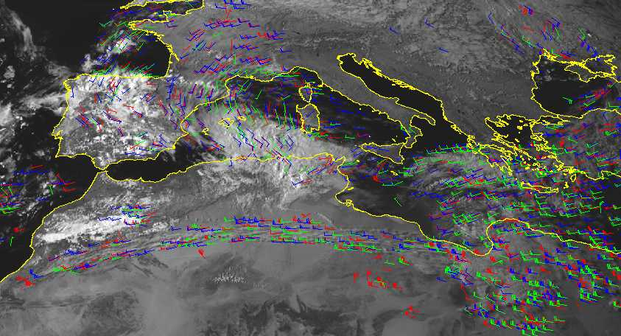
Figure 1. Atmospheric Motion Vectors derived with Meteosat-8 data. Please note the well-depicted high level jet over Northern Africa derived from very thin cirrus.
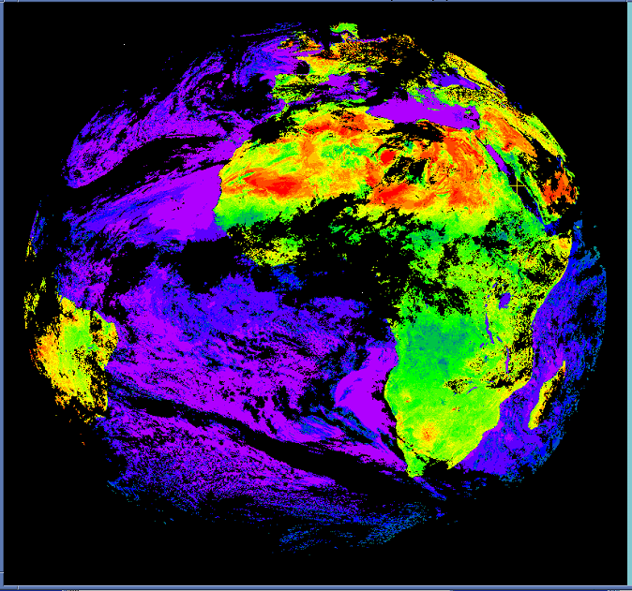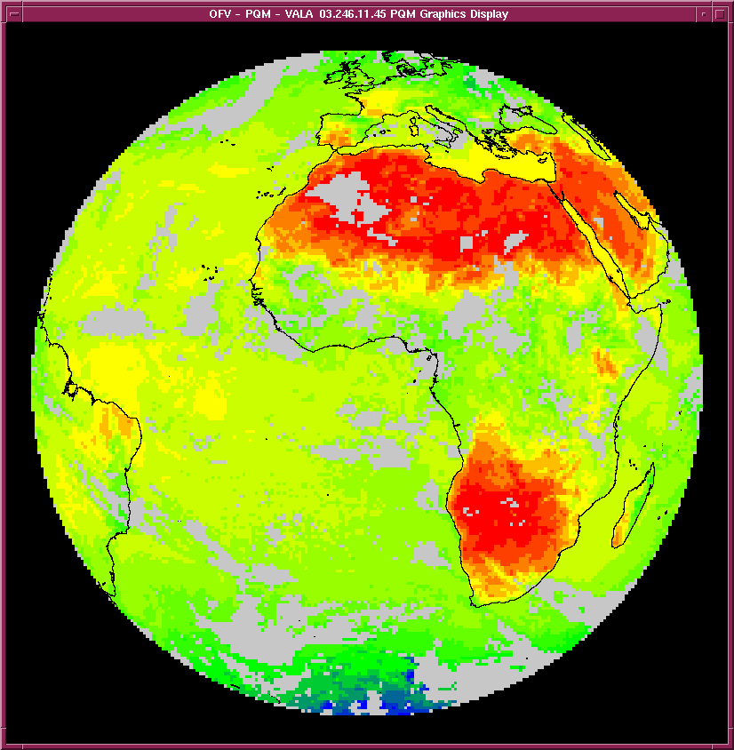
Figure 2. Clear-sky reflectance Map derived with accumulated data from a visible channel and a Clear Sky Radiance product for the IR window channel derived with Meteosat-8.

3. Meteosat-8 dissemination

Due to a failed Solid State Power Amplifier (SSPA) the Meteosat-8 onboard dissemination capability cannot be used. Therefore an alternative dissemination method EUMETCast has been put in place. The EUMETCast system relies on commercial telecommunications satellites and disseminates all image data and products over the European region in Ku-band. The system is currently used for data from the first and second generation Meteosat satellites and the EUMETSAT ATOVS Retransmission System. (Figure 3.) Additionally data from some European meteorological Services are included. For the African region a turn-around system is used to further disseminate the data in C-Band, where a Ku-band reception station in Italy is re-transmitting the data via C-band. The current bandwidths of the Ku and C-band are 2.5 and 2.7 Mbps respectively. Additionally, the Meteosat-8 data is provided to US (Wallops) via a dedicated landline.

Figure 3. The EUMETCast data distribution system.
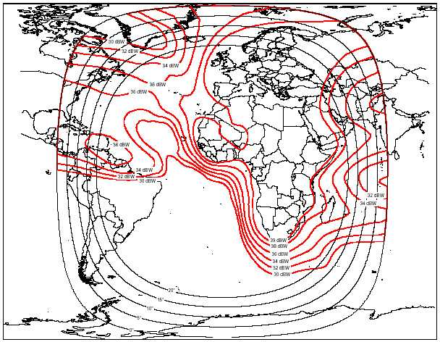

Figure 4. The C-band coverage of EUMETCast.
Currently, the main shortcoming of the alternative dissemination is limited coverage in South-America as shown in Figure 4. Various solutions for the South-American coverage are currently explored.

4. The EUMETSAT ATOVS Retransmission System

The EUMETSAT ATOVS Retransmission System (EARS) is currently covering roughly 2/3 of the Northern Hemisphere ensuring a data timeliness of 30 min within observation for the ATOVS level 1c data. The current data coverage, with coverage frequency indicated, is given in Figure 5. EUMETSAT is currently looking for an extension of the EARS service that would further improve the coverage, include limited retransmission of AVHRR data (over Europe), include ASCAT data after the launch of METOP-1 and to continue the service until the end of 2008.
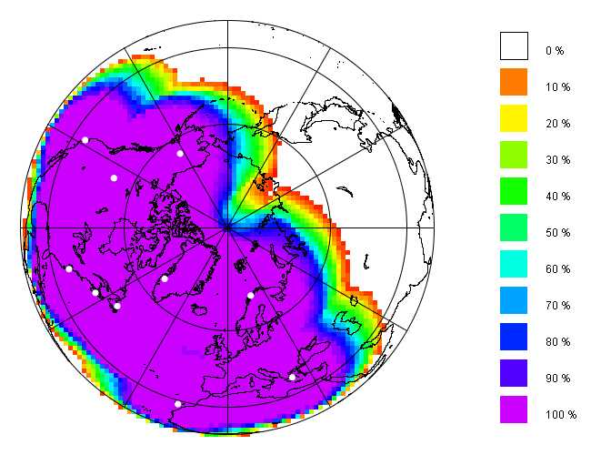
Figure 5. The current EARS data coverage.

5. The EUMETSAT Polar System

The first EUMETSA Polar System Satellite, METOP-1 is planned for launch in the 4th quarter of 2005. One important current activity is the provision of updated information, test data, formats and tools to the users. The information is provided sequentially and the first sets are already available on the EUMETSAT WEB site at:
http://www.eumetsat.de/en/area4/eps/user_information.html

6. JASON-2

The Jason-2 optional programme was started in June 2003 when 13 EUMETSAT Member States confirmed their subscription to the project, covering 90 percent of the 30 million euros needed for the programme. Jason-2 follows the Jason-1 and TOPEX/Poseidon missions begun in December 2001 and in 1992 respectively. Jason-2 is intended to overlap with Jason-1 to allow more precise cross-calibration between the two systems within a few tens of millimetres. EUMETSAT will host the European Earth terminal to retrieve data and to process and distribute Near Real Time products to users. The involvement of EUMETSAT and NOAA – two operational agencies - marks the programme’s transition to operational oceanography. When real time support becomes available, the programme will assist offshore operations and ship routing services, among others. JASON-2 is currently foreseen to be launched in 2008.

ATTACHMENT-VIII: ECMWF Status Report (H. Böttger/J.-N. Thépaut)

ECMWF status report not submitted but presentations as PowerPoint files (provided by H. Böttger and J.N. Thépaut) available on the CD ROM or from Gilles Verner

ATTACHMENT-IX: METO Status Report (R. Saunders)


Dated: 21 May 2004

The Met Office (U.K.) status report to 17th N. America-Europe Data Exchange Meeting at Dorval, Canada 26-28 May 2004
Roger Saunders, NWP/SA, Met Office,Exeter, EX1 3PB, U.K.

- Introduction

This report describes changes to the use of U.S. satellite and in-situ data in the Met Office NWP models and other forecasting systems since the last Data Exchange Meeting in May 2003. Changes to the Met Office NWP models and assimilation systems are now regularly documented in the NWP gazette which is available on line at: http://www.metoffice.com/research/nwp/publications/nwp_gazette/. There are also technical reports on NWP available at: http://www.metoffice.com/research/nwp/publications/papers/index.html

The relocation of the Met Office headquarters building from Bracknell to Exeter (~200km to the south west) was successfully completed on time. The new building was completed in December 2003 at which time the majority of the staff had relocated. More than 70% of the staff moved to Exeter. All of the links to Washington, Dorval and European Met Services are now established at Exeter rather than Bracknell. The new site can be viewed at:
http://www.metoffice.com/corporate/relocation/ .

The NWP models were successfully ported to the new NEC SX-6 computers and operations began on the new machines on 27 April 2004. The old Cray T3Es are now being disposed of.

1.1 Model and assimilation changes

There have been no changes to the global model, a 1:50hr data cut off is used. An ensemble forecasting system is planned with 16 members out to T+72hr at 80km resolution. The new Eurolam model with a 20km grid has become operational on 23 March 2004 and is run 4 times a day with forecasts out to T+48hr. It is planned to make the products more widely available to customers in late 2004.

Due to the relocation of the Met Office there have been no major changes in the data assimilation or data usage over the past year but there is a new package of satellite data changes planned for late May 2004 which is described below. A summary of the observations used in the global model is given in Table 1. Work on 4D-Var at the Met Office has continued and an initial implementation is being planned within the next six months for the global model and during 2005 for the Eurolam model.

1.2 ATOVS radiances

The brightness temperatures (BTs) in the Level 1B ATOVS datasets (HIRS, AMSU-A and AMSU-B) from NOAA-15,16 and 17 mapped to the HIRS fovs, are continuously monitored by comparing with calculated BTs from the 6 hour global forecast. The link to the monitoring plots has changed and can now be viewed at: http://www.metoffice.com/research/nwp/satellite/radiance/atovs/main.html . Feedback on these plots is welcomed to nwpsaf@metoffice.com. Monitoring of the instrument housekeeping parameters also continues for AMSU-A and AMSU-B on all 3 NOAA platforms.

Observation group | Observation  Sub-group | Items used | Daily extracted | % used in  assimilation
Ground-based vertical profiles | TEMP  PILOT  PROFILER | T, V, RH processed to model layer average  As TEMP, but V only  As TEMP, but V only | 1200  900  3200 | 97  90  75
Satellite-based vertical profiles | ATOVS  NOAA-15/16  AIRS, AMSU-A  AQUA | Radiances directly  assimilated with channel selection dependent on  surface instrument and cloudiness | 430000  (AIRS not included) | 3  (AIRS not included)
Aircraft | Manual  AIREPS  Automated ACARS/AMDAR/ASDAR | T, V as reported with duplicate checking and blacklist | 25000  120000 | 21  60
Satellite atmospheric motion vectors | GOES 10,12 SATOB  Meteosat 5, 7 BUFR  GOES 9 SATOB | High resolution IR winds  IR, VIS and WV winds  IR, VIS and WV winds | 110000  190000  4000 | 10  5  55
Satellite-based  surface winds | SSMI-13,15  Seawinds | In-house 1DVAR wind-speed retrieval  NESDIS retrieval of ambiguous winds. Ambiguity removal in 3DVAR. | 3000000  1800000 | 1  1.5
Ground-based  surface | Land SYNOP  SHIP  BUOY | Pressure only (processed to model surface)  Pressure and wind  Pressure | 30000  6000  9500 | 80  90, 95  75
Table 1. Observations assimilated into global model.
The Met Office generates Level 1C ATOVS datasets (i.e. geolocated brightness temperatures), which are passed to ECMWF, DWD and MétéoFrance and are potentially available to other European NWP Centres. The generation of level 1C NOAA-16 AVHRR parameters on the HIRS fields of view is also operational and provided to ECMWF. The ATOVS level 1C data are pre-processed to level 1D (i.e. brightness temperatures of all ATOVS channels mapped on to the HIRS grid) which are then used in the Met Office global NWP models and also passed to the Bureau of Meteorology in Melbourne. There are still significant delays in the global ATOVS 1B files at some periods of the day due to the ‘blind orbit’ delays. To investigate the impact of the ATOVS data delays on the NWP forecasts a data impact experiment was run where all the late data was included in the main forecast run. The results showed with our 1:50 hr cut-off that significant improvements in the forecasts over both the Northern and Southern Hemispheres were seen by including the late data even though an update run is used for the next cycle of the data assimilation which includes these data. The results are available from the following link:
http://www.ecmwf.int/newsevents/meetings/workshops/2003/9th_Meteorological_Operational_Systems/presentations/Saunders.pdf This underlines the importance of receiving the ATOVS data in a more timely manner for operational NWP.

To mitigate the data delays the Met Office is also processing the level 1A data received from the EUMETSAT EARS system, which currently comprises of downloaded ATOVS from 9 stations using AAPP. Routine monitoring of the differences between the EARS data and the global 1B ATOVS data is carried out. These data are now assimilated in the global and EUROLAM models due to their much improved timeliness which fills gaps over the Atlantic Ocean due to the late arrival of ATOVS data from NESDIS.

The ATOVS data from NOAA-17 was no longer assimilated after October 2003 due to the failure of AMSU-A1 on that platform. As a result to improve the robustness of the satellite data provision the AMSU-A data from Aqua has been introduced from 25 May 2004. Although the Aqua platform is in an orbit similar to NOAA-16 it can sometimes provide AMSU-A data before the NOAA-16 data resulting in positive forecast impacts.

A new radiance bias correction, expanding the use of both IR and microwave data over land/ice, has also been implemented on 25 May 2004.

A project has commenced to prepare for the assimilation of METOP data, initially ATOVS and ASCAT but with plans to also quickly exploit the data from the IASI and GRAS instruments.

1.3 Advanced infra-red sounders (AIRS)

The Met Office continues to provide monitoring statistics of the AIRS 324 channel radiances + AMSU-A on Aqua in near real time on the web at: http://www.metoffice.com/research/nwp/satellite/infrared/sounders/airs/index.html
(userid: airspage; password: &Graces). Assimilation experiments to assess the forecast impacts with the AIRS data have shown positive results in both hemisphere and as a result AIRS radiances from a subset of ~80 channels are now used operationally in the global model. This is a conservative use of AIRS data and it is planned to gradually use more of the data to increase the impact.

1.4 SSM/I & SSMIS

Orbit-by-orbit brightness temperatures are received from F-13, F-14 and F-15 in near real-time from NESDIS. These data are passed to ECMWF where they are BUFR-encoded and returned to Exeter for onward transmission to other European centres.

The brightness temperatures are processed through a 1D-Var analysis which provides retrieved total column water vapour, surface wind speed and cloud liquid water path. Surface wind speeds from both F13 and F15 continue to be assimilated. Experiments are continuing with assimilating the total column water vapour and recent results have shown some positive benefits.

It is planned to process SSMIS radiances as soon as they become available for comparison with the NWP model and ultimately to assimilate these radiances with a common processing software with ATOVS. It is frustrating how long it is taking for the SSMIS radiances to be released which we are now expecting within a few weeks.

1.5 Scatterometers

Seawinds observations are received from NESDIS and since 11 Dec 2002. The directionally ambiguous winds have been assimilated in the global model with the ambiguities being removed with the 3DVAR scheme. Under the NWP SAF, monitoring of Seawinds is reported at:
http://www-nwp/research/interproj/nwpsaf/scatter_report/index.html

ESA have introduced a revised processing scheme for the ERS Scatterometer which can compensate for the satellite’s yaw-steering problem. ERS-2 scatterometer data have been available on the GTS again since October 2003; validation has shown the recent ERS-2 scatterometer winds to be of at least the same quality as that prior to the gyro failure in February 2001. ERS winds are being monitored but there are no plans to assimilate these data at present.

1.6 Altimeters and in-situ ocean data

The Met Office receives altimeter data products twice a week from the DUACS/SSALTO centre in Toulouse and assimilates them into the FOAM models, which are run daily in the operational suite. Altimeter data are available from the US Navy on a daily basis and we plan to investigate them when resources allow.

1.7 SST products

Retrieved AVHRR SSTs obtained from NESDIS in SATOB format are used in the operational global SST analysis. In addition data at 1º resolution and twice weekly data at 0.5º resolution are being delivered to the Met Office and a system has been developed to replace the SATOB data with the 0.5º/1º data in the near future.

NOAA-16+17 SSTs are retrieved from locally-received AVHRR data (covering N. Atlantic) for assimilation in the mesoscale model's SST analysis. It is planned to replace this with a product from the Ocean Sea-Ice SAF in the near future.

AATSR top of atmosphere brightness temperatures and SSTs from ENVISAT are received from ESA in near real time. It is planned to use these data for both NWP and climate model SST analyses. The skin SSTs are accurate to 0.3 K. A monitoring web page for AATSR SSTs is at:
http://www.metoffice.com/research/nwp/satellite/infrared/aatsr/index.html
with user id: aatsruser, password: sst4you .

1.8 Snow and Sea-ice products

The NESDIS Interactive Snow and Ice Mapping System data were used to compare with the global model N. Hemisphere diagnosed snow and ice fields from June 2002. A report is available on the comparisons at:
http://www.metoffice.com/research/nwp/publications/papers/technical_reports/2003/FRTR416/FRTR416.pdf
Longer term plans are to assimilate these data into a surface analysis.

The NCEP sea-ice analysis continues to be used operationally in the global NWP systems.

1.9 Cloud-tracked winds

GOES IR winds (thinned to one per 2 deg box) continue to be assimilated and monitored. The details of the current use of the winds in the global model are at:
http://www.metoffice.com/research/interproj/nwpsaf/satwind_report/ukmodel.html
The monitoring results are at:
http://www.metoffice.com/research/interproj/nwpsaf/satwind_report/index.html
The GOES-10/12 SATOB and BUFR winds, MODIS Aqua and Terra polar winds are all being monitored. We are running forecast impact experiments with the GOES BUFR and MODIS winds processed at NESDIS. The latter are showing positive impacts. We require any improvements implemented for the NESDIS MODIS winds be made available without delay. We are also keen to see the NESDIS winds available on the GTS as soon as possible, at least by early next year. We also use the JMA GOES-9 winds in place of the GMS-5 winds.

A new superobbing scheme has been developed by a visiting scientist from CIMSS as a potential improvement to the use of thinning for dealing with the high density satwind data-sets. Data assimilation trials are underway.

1.10 Polar and Geostationary Imagery

Forecasters make use of the images on the NOAA PSB polar WEFAX product internet site. We are still working with NESDIS to add the overpass times to the image products so that the forecasters know the valid time of each overpass. NOAA GAC polar composites are also copied once or twice a day to Exeter as a backup to the products on the internet.

The generation of products from the new MSG (Meteosat-8) satellite has begun. Images are received from the DVB broadcast system and processed in real time to provide clear sky radiances and cloud top height for the nowcasting systems. Volcanic ash and fog imagery are also produced.

1.11 Profiler data

The U.S. profiler data continue to be assimilated in 3D-Var. More data will be used when 4D-Var becomes available later this year. The European profiler data are monitored and a report is issued quarterly. Currently about 30 of the European stations are assimilated based on their monitoring statistics. The wind profiles from the weather radars are also now being assimilated.

  - Ozonesonde Ascents

The Met Office has been launching ozonesondes from Lerwick once a week (normally Wednesday at 12Z) and the ascents are encoded into BUFR and put out on the GTS in near real time. They are also stored in the NILU archive in Norway.

  - NWP Satellite Application Facility

The NWP Satellite Application Facility (SAF) reached the end of its 5 year development phase in February 2004. A 3 year initial operational phase has now begun. Activities include:
- Maintaining and developing AAPP software for processing of ATOVS data.
- Maintaining and developing the fast RT model RTTOV.
- Producing cloud track winds monitoring reports from several NWP centres.
- NWP monitoring of scatterometer winds.
- NWP monitoring of ATOVS radiances.
- Developing NWP interface software for METOP sensor radiances.
For more details the NWP SAF web site is at: http://www.metoffice.com/research/interproj/nwpsaf/index.html

  - GRAS Satellite Application Facility

The GRAS (GNNS Receiver for Atmospheric Sounding) Satellite Application Facility (SAF) reached the end of its 5-year development phase in April 2004. A 3-year Extension Phase has now begun. Met Office activities include:
- Specification of Level 2 data formats for NRT & offline dissemination to users
- Developing ROPP (Radio Occultation Processing Package) software for the pre-processing of GRAS and other radio occultation mission (CHAMP, COSMIC, etc) data.
- Developing NWP interface software for the assimilation of RO data
- Monitoring of GRAS sounding products.
For more details the GRAS SAF web site is at:
http://web.dmi.dk/pub/GRAS_SAF/

ATTACHMENT-X: M-F status report (B. Lacroix /H. Roquet)

17th North America - Europe data exchange meeting
Météo-France status report

Bruno Lacroix (COMPAS)/ Hervé Roquet (CMS)
Météo-France
42, av. Coriolis, F-31057 TOULOUSE Cedex

Supercomputers:
The present configuration is two Fujitsu VPP5000 since August 2003:
Operational computer with 60 processors (50 with 4 Gbytes memory, and 10 with 8Gbytes)
Research computer with 64 processors (53 with 4 Gbytes memory, and 11 with 8Gbytes).
The efficiency is 3.2 Gflops per processor.
This will be the supercomputer configuration until end 2006.

Models configuration:
ARPEGE global spectral stretched model T_{L}358 C2.4 (stretching factor real truncature varying from 358 *c over France to 358 / c) , 41 levels from 17m to 1hPa:
The stretching factor 2.4 leads to a resolution of 23 km at the center of France, and 133km over New Zealand.
The orography is truncated to T_{L}240 C2.4.
The 4D-VAR multi-incremental assimilation resolutions are T_{L}107- T_{L}149 C1L41, with a 6-hour window.
ALADIN regional spectral model E149x149 L41over France
300x300 grid points in physical space with 9 km resolution, coupled with ARPEGE every 3 hours. There is no data assimilation (dynamical adaptation).
Cyclone model:
Twice a day, at 00 and 12UTC, a uniform configuration called ARPEGE-Tropiques is run, with an experimental status. The geometry is T_{L}359L41, which is equivalent to 55 km grid point resolution (T_{L}240 orography).
The assimilation is a 4DVAR scheme, whose geometry is T_{L}107 C1 L41. It includes bogussing for cyclone position and a specific tuning for SATOB data use.
Climate model:
9 lagged runs a month for 4 month forecast, starting from ECMWF analysis, with SST forcing.
The model used is ARPEGE-Climat T_{L} 63L31
Experimental Ensemble System:
An ensemble based on ARPEGE stretched configuration T358C2.4L41, with 10 runs with 60H range, is produced in experimental mode.
The perturbations are made using singular vector method (optimized on a 24H time window with a total energy norm).
Operational suite scheduling:
HH | 0000 UTC | 0600 UTC | 1200 UTC | 1800 UTC
ARPEGE short / long cut-off | 1H50 / 8H15 | 3H / 6H50 | 1H50 / 8H15 | 3H / 6H50
ARPEGE range | 102H | 72H | 72H | 60H
ALADIN range | 54H | 48H | 42H | 36H
Tropiques short / long cut-off | 3H50 / 9H55 | 8H | 3H55/9H10 | 8H
Tropiques range | 72H |  | 72H
Boundary conditions
ARPEGE produces boundary conditions for the ALADIN applications run in Prague for ALADIN central Europe, in Morocco, Romania and Bulgaria, Poland, Portugal.
ALADIN-France provides boundary conditions for ALADIN-Belgium.
An ALADIN–Tunisia version is also running at Toulouse for Tunisia.
Data used in global model assimilation:
All SYNOP, SHIP, BUOY, TEMP, TEMPSHIP, TEMPDROP, PILOT, AIREP, AMDAR, ACARS, US and European profilers.
All Cloud motion winds (GOES 9, 10 and 12) in SATOB code, and (Meteosat 5 and 7) in BUFR with quality index.
AMSU-A radiances (NOAA15 and NOAA16), HIRS radiances(NOAA16 and NOAA17).
SSM/I for sea ice mask in SST analysis + SST 0.5 degree from NESDIS.

Telecommunication:
Daily volume of satellite data files received at Toulouse (Mbytes):
HIRS (38 Mbytes), AMSU-A(18 Mbytes), AMSU-B(75Mbytes) from NOAA15, 16 and 17: total 350Mb
SMM/I (130 Mbytes) from DMSP F13 and F15
Seawind (160 Mbytes) from Quikscat
AIRS (250 Mbytes) from Aqua
Links relevant to US/Europe data exchange:
PVC from Toulouse to | CIR (kbps) in | CIR (kbps) out
United Kingdom | 256 | 128
French West Indies | 128 | 128

PVC from Lannion to | CIR (kbps) in | CIR (kbps) out | MIR (kbps) in | MIR (kbps) out
Suitland | 64 | 64 | 256 | 256
Darmstadt | 64 | 64 | 256 | 256
Toulouse | 2 Mbps | 2 Mbps | 4 Mbps | 4 Mbps
Lannion-Suitland link:
Lannion to Suitland: Meteosat 5 (IODC) imager data (3 channels at full resolution every 30 minute) and AVHRR data received at Lannion
Suitland to Lannion: GOES-10 and KALPANA (test purposes) imager data for FSDS service of Eumetsat
Lannion-Darmstadt link:
Lannion to Darmstadt: GOES-9, GOES-10, GOES-12 and KALPANA (test purposes) imager data (VIS and IR every 3 hour) for FSDS service of Eumetsat
Lannion-Toulouse link:
Toulouse to Lannion: GOES-9 imager data for FSDS service of Eumetsat, received from Melbourne via Exeter

Details on use of US data:

NOAA15, 16, 17
Level 1C AMSU-A
Used operationnaly since 22 october 2002
Improvment in data quality control (more severe and asymetric test to detect clouds) since 8 December 2003. Sampling 1 over 2 ~ 140km.
Impact studies have been performed with ARPEGE uniform configuration to test :
- Impact of long cut-off time positive impact over Europe
- Impact of Regional acquisition with Eumetsat of ATOVS data (EARS) weak positive impact over Europe
Level 1C HIRS (new data stream)
Used operationnaly since 8 December 2003 (channels 4-5-6-7 , 11-12 and 14-15), sampling of 1 over 4 ~150km, and thinning 250km).
The HIRS raw radiances are used for ozone computations and comparison to other sources (ground stations, TOMS/Earth Probe and GOME/ERS-2), which are performed globally on research mode. To test SAF-ozone operational suite, an experimental product of HTO=Hirs/4 Total Ozone, which will be derived from Metop 1 and 2, is copied daily on cnrm-ftp.meteo.fr:/pub-eram/o3saf. At present, HIRS data from NOAA16 are processed.
AMSU-B (under developpment)
Test ongoing to use 3 channels (3-4-5) with a sampling (1 over 6 in each scan).
Scan and air-mass correction.

GOES 9, 10, 12
GOES SATOB winds: SATOBs (InfraRed, Visible and Water Vapor) monitored and used with a thinning (1 per 2.5 degree box, since 4 may 2000) to cope with high-resolution data in ARPEGE analysis. The BUFR products with Quality Index are not used for the moment. Nevertheless, the quality index from Meteosat BUFR details now used.

Météo-France/CMS is processing operationally GOES-E (currently GOES-12) imager data from the direct GVAR reception, to elaborate image products, cloud products, and SST and radiative fluxes products (the latter products are processed and distributed in Europe in the framework of the EUMETSAT Ocean and Sea Ice SAF).

MODIS winds (under developpment)
Impact studies performed with test data set from Terra (3 weeks).

AIRS radiances (under developpment)
Impact studies performed with 176 channels over clear pixels and a flat bias correction.

DMSP F13, F15
SSM/I: Maps are produced 4 times a day for forecasters (humidity, wind speed, snow and flag of rain) and sea-ice once a day.
SSM/I sea ice mask is produced once a day for SST analysis purpose.

Quikscat
The winds produced by Seawind are available on SYNERGIE software for Marine forecasters.
Preliminary development to preprocess data to use them in 4DVAR assimilation. Impact studies are being set up.

ACARS
ACARS: Monitored and used operationally (wind and temperature) in the NWP system, with a thinning (1 in 5, since 8 mars 1999). All phases (cruise, ascent and descent) are used.

PROFILERS
Used operationnaly since 22 october 2002.

SST analysis:
The 0.5 degree SST field is acquired once a day by ftp and used by ARPEGE model as relaxation to climatology in data sparse area. The 1-degree SST product is no more used at Météo-France.

French/European data

Air France aircrafts:
AMDAR messages on the GTS coming from 40-45 units based on ACARS, as part of the Eucos network. No cruise phase data is produced.

Profiler:
The VHF 52.05 MHz profiler has been installed since end 1995 at La Ferté-Vidame (110km SW from Paris. Its data are sent to the GTS on BUFR code, using the European sequence of descriptors. The header bulletin is IUPN40LFPW.
2 other profilers are installed, in Nice and Marignane, but the data are not good enough to be transmitted on the GTS. They are nevertheless sent to Eumetnet members for evaluation, in the project WINPROF.

BUFR for Tropical cyclone
According to 3rd tropical cyclone RSMCs technical coordination meeting, until October 2001 Meteo-France RSMC in La Reunion has implemented FM 94 BUFR format for the diffusion of information on tropical storms and cyclones in SW Indian Ocean in GTS. (GTS Header ICXL20 FMEE)

JASON
JASON data has been on GTS since May 2003 (GTS headers: ISZ(A-L)01 LFPW).

Meteosat 8
Météo-France/CMS is receiving the Meteosat 8 Imager data through the EUMETCAST system. Météo-France/CMS has implemented two EUMETCAST Ku-Band systems and one C-Band system for back-up, and is processing operationally the Imager data to elaborate image products, cloud products and SST and radiative fluxes products (the latter products are processed in the framework of the EUMETSAT Ocean and Sea Ice SAF). The Meteosat 8 based Ocean and Sea Ice SAF products are now in the process of their Operational Readiness Review. Météo-France/CMS is also producing full resolution Meteosat 8 IR radiances and cloud information which are sent to Toulouse for assimilation in ALADIN system (end 2004).

EARS
Météo-France/CMS is receiving the EARS data through the EUMETCAST system. Météo-France/CMS is processing EARS ATOVS leval 1a data in combination with locally received ATOVS level 1a data, to reconstruct as long orbits as possible, and to produce fully consistent ATOVS level 1c data which are sent to Toulouse with a short delivery time for assimilation in ARPEGE (summer 2004) and ALADIN (end 2004) systems.

Contact points
Satellite winds and Quikscat: Christophe Payan christophe.payan@meteo.fr
AIRS: Thomas Auligné thomas.auligne@meteo.fr
ATOVS and SSM/I : Elisabeth Gerard elisabeth.gerard@meteo.fr
HIRS/ozone Fernand Karcher fernand.karcher@meteo.fr.
JASON Bruno Lacroix bruno.lacroix@meteo.fr

Future Plans

Concerning data assimilation, the following actions are planned:
- AIRS, AMSUB, Quikscat and EARS ATOVS (summer 2004)
- 3DVAR Data assimilation for the limited area model ALADIN-France (End 2004)
- Use of Water Vapor Geostationnary radiances (Meteosat 8) in 3DVAR ALADIN (End 2004)
- Assimilation of BUFR winds with quality index (Early 2005)
- Assimilation of MODIS winds (2005)
- New procedure to unbias radiosonde temperature (radiation correction).
- GPS ground data in ALADIN (2005)
- GPS radio-occultation in ARPEGE (2006)

ATTACHMENT-XI: DWD Status Report (R. Hess)

Deutscher Wetterdienst status report submitted as a pdf file, as well as PowerPoint presentation (provided by R. Hess) are available on the CD ROM or from Gilles Verner.

ATTACHMENT-XII: TOC Telecommunications Status Report (F. Branski)

The TOC PowerPoint files covering Telecommunications as well as WMO Codes Migration (provided by F. Branski) are available on the CD ROM or from Gilles Verner. In addition the following four topics have been covered by TOC and are included as sub-attachments.

ATTACHMENT-XII-I: International Satellite Communication System (ISCS)

The ISCS is composed of two systems for data delivery via satellite communications. The first system is the World Area Forecast System (WAFS) in support of the International Civil Aviation Organization (ICAO) program for aviation data distribution. The WAFS broadcast makes globally available to aviation users the centrally produced aviation model forecast products of a World Area Forecast Center (WAFC) in global gridded binary form (WMO GRIB code), Alpha-numeric text, facsimile graphics ( T4-FAX format), and satellite imagery (GIF format) data types. T4 FAX will be replaced by binary graphics (BUFR) data format in 2004.

The second part of the ISCS is the Region IV Meteorological Telecommunications Network (RMTN) satellite system which replaced the two WMO Region IV GTS regional communication networks of the Antilles Meteorological (ANMET) and Central America Meteorological (CEMET). The RMTN supports WMO GRIB, alpha-numeric text, and T4-FAX data types. T4 FAX will be replaced by binary graphics (BUFR) data format in 2004.

The United States will continue to support ICAO/WMO requirements (as a servicing World Area Forecast Center - WAFC) with the ISCS.
The global coverage will continue to span approximately from 105degrees east longitude to 65 degrees east longitude (covering the Pacific Ocean, Atlantic Ocean, North America, Central America, South America, and the Caribbean).

The ISCS system has all data originating from the NWSTG. This data is sent via TCP/IP socket to the ISCS service provider (MCI). The service provider bundles the data into files that are uplinked over the Atlantic and Pacific regions for reception. The file broadcast method is proprietary and users are required to sign a license agreement in order to receive the data stream.
The sockets are defined as follows:

Socket 1: WAFS, WMO GRIB
Socket 2: WAFS, Alphanumeric data messages
Socket 3: WAFS, Graphical T4 coded data.
Socket 4: RMTN-IV Gridded Binary (GRIB) code data,
Socket 5: GTS Alphanumeric data (primarily synoptic and text) (AOR oriented),
Socket 6: RMTN-IV Graphical data (analysis and significant weather).
Socket 7: Gridded Binary (GRIB) code data (POR Oriented),
Socket 8: GTS Alphanumeric data (primarily synoptic and text) (POR oriented),
Socket 9: Graphical data (analysis and significant weather) (POR Oriented).

To support the Region IV Meteorological Telecommunications Network (RMTN) requirements there are 2-way sites that can send and receive data. Their means of transmitting data is via FTP to the NWSTG over the same satellite channel that they receive data. FTP accounts are specified for each 2-way site complete with unique userids and passwords.

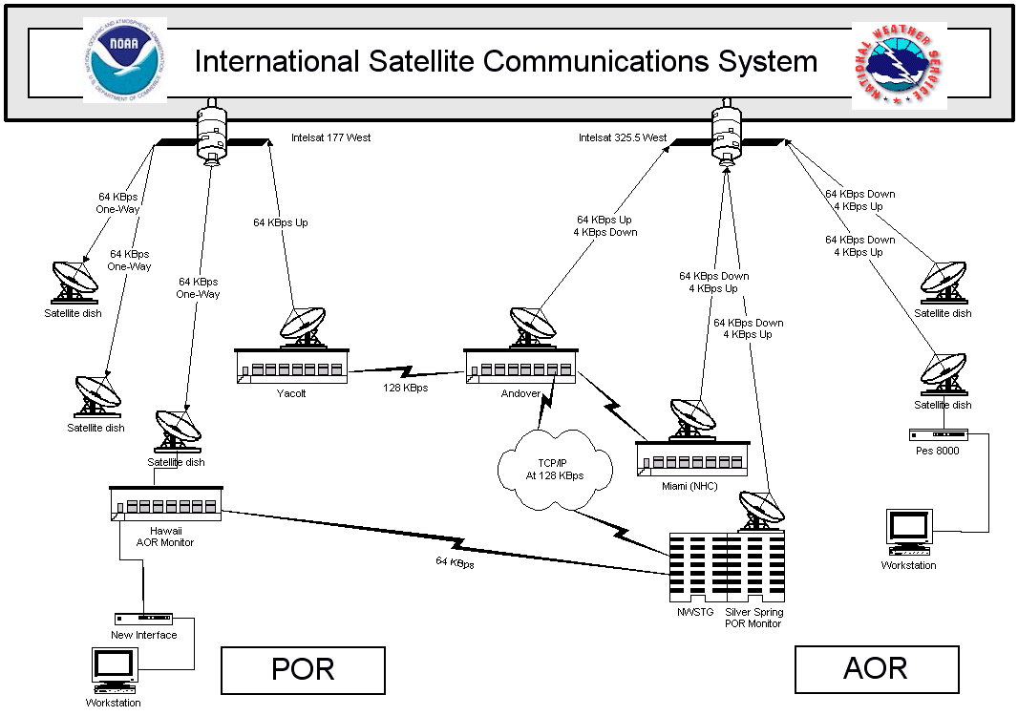

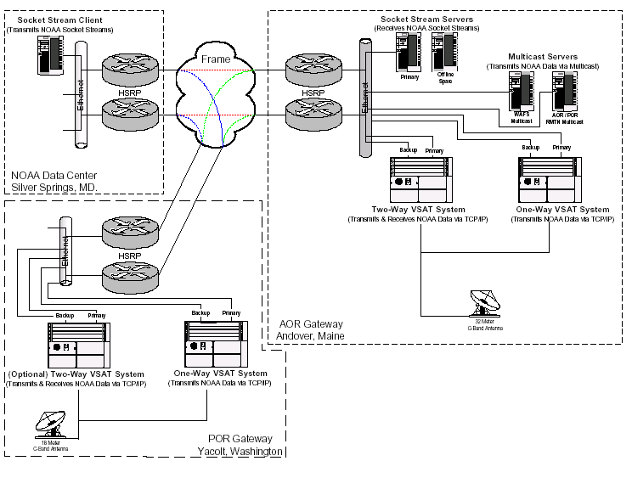

ATLANTIC OCEAN REGION (AOR)

The AOR portion of the successor ISCS will be centered at the WorldCom shared Master Satellite Hub, in Andover, Maine.
The Master Satellite Hub will be linked via a 128 Kbps (384Kbps bursting) terrestrial (redundant) circuit to the National Weather Service Telecommunications Gateway (NWSTG) in Silver Spring, Maryland.
The NWSTG will continue to serve as the central point of data entry into the ISCS.
All ISCS data originating at the NWSTG will be transmitted, using TCP/IP network protocol, over to the WorldCom Andover facility for broadcast to all ISCS AOR sites.

PACIFIC OCEAN REGION (POR)

The POR portion of ISCS will be centered at the WorldCom shared Master Satellite Hub in Yacolt, Washington.
The Yacolt Master Satellite Hub will be linked via a 64 Kbps (128Kbps bursting) terrestrial (redundant) circuit to the WorldCom shared Master Satellite Hub in Andover, Maine.
All ISCS WAFS data originating at the NWSTG will be transmitted, using TCP/IP network protocol, to the Yacolt facility (via the Andover facility) for broadcast to all POR sites.
Future plans include 2-way sites in the Pacific Ocean Region

BACKUP

The ISCS has increased the number of Backup options. Multiple ISDN dialup connections between the Andover Hub, UK WAFC, the Aviation Weather Center (AWC) Kansas City, and the eventual NWS Mt. Weather disaster recovery site.

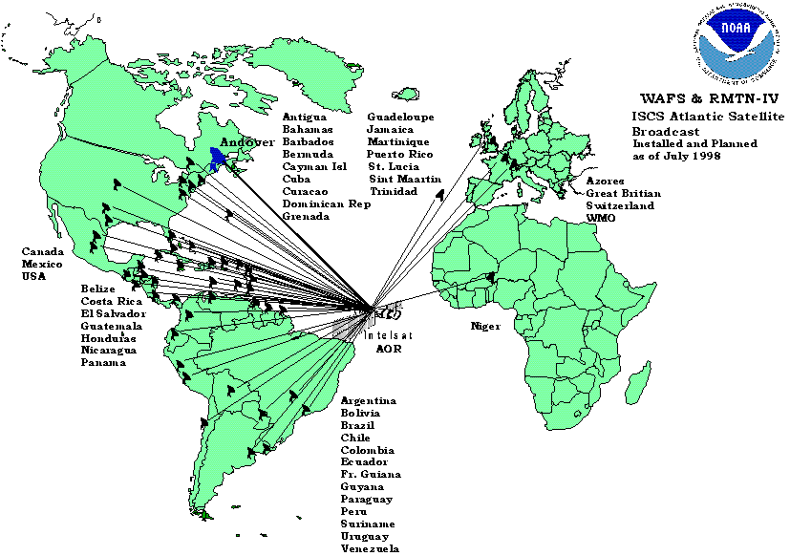
ATLANTIC OCEAN REGION (AOR)

The AOR portion of the successor ISCS will be centered around the WorldCom shared Master Satellite Hub, in Andover, Maine.
The Master Satellite Hub will be linked via a 64 Kbps (128Kbps bursting) terrestrial (redundant) circuit to the National Weather Service Telecommunications Gateway (NWSTG) in Silver Spring, Maryland.
The NWSTG will continue to serve as the central point of data entry into the ISCS.
All ISCS data originating at the NWSTG will be transmitted, using TCP/IP network protocol, over to the WorldCom Andover facility for broadcast to all ISCS AOR sites.

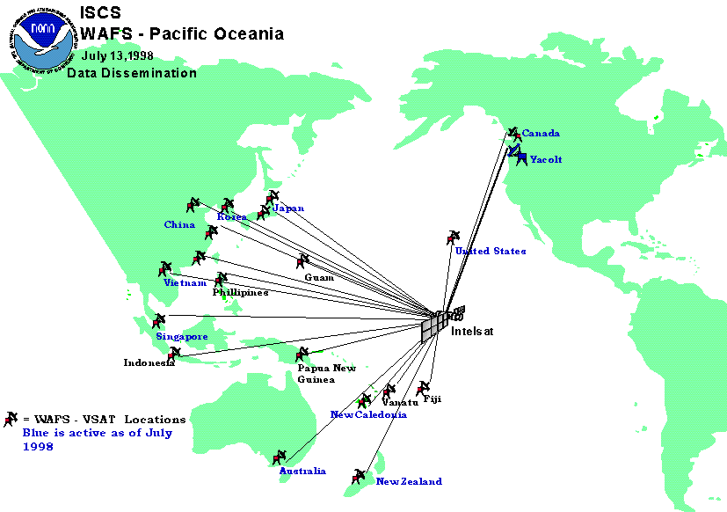
ISCS WAFS – Pacific Ocean Region

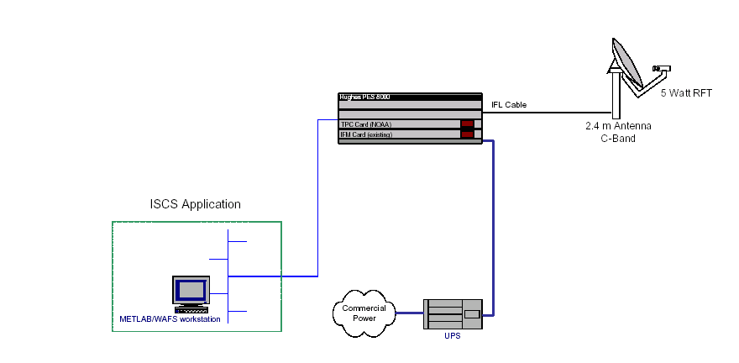
Note:
Remote Terminal consists of a 2.4m C-Band Antenna and PES 8000 Indoor Unit
PES 8000 is configured with one (1) Turbo Port Card
Interface Card for NWS includes an Ethernet PLC and provides 10 Mb RJ45 Connection
ISCS Two-Way Site Configuration
IP

Note:
- Remote Terminal consists of a 2.4m C-Band Antenna and PES 8000 Indoor Unit
- PES 8000 is configured with one (1) Turbo Port Card
- Interface Card for NWS includes an Ethernet PLC and provides 10 Mb RJ45 Connection

ISCS Receive Only Site Configuration

2.4 m
Antenna
C-
Band
UPS
IFL
Cable
Star 4
Notes:
1. Remote terminals consists of a 2.4 meter C-Band Antenna and Personal Earth Station
(PES) Indoor unit with a Memotec unit and Star4 workstation.
2. Two way sites have the PES 8000 that will only need a new card installed for TCP/IP.
3. The one way sites will have the PES 4000 replaced by the COMTECH CDM-IP 300L.
5. Both site types will have upgraded workstations that connected by Ethernet.
Junction
Box
Memotec
Existing Configuration
TCP/IP Upgrade
Configuration
Hughes PES
8000
Commercial
Power
Met Lab
Firewall
Local dial in
E
t
h
e
r
n
e
t
Comtech
CDM-IP 300L

ATTACHMENT-XII-II: NWS Web Bulletin Input Form Guidance Documentation

This is an automatic process and every message submission will be disseminated world-wide as determined by the routing established for the WMO abbreviated heading you used. The submitting NMC is responsible for content. This capability requires prior establishment of procedural controls. You must email a request for access to RTH Washington.

GUIDANCE ON FILLING OUT THE WEB DATA FORM

The WMO Bulletin
(See WMO Message Structure for Full Details)

1. The webpage information submitted on this input form is the WMO bulletin
2. The content of the WMO bulletin is:
An abbreviated heading line
T1T2A1A2ii CCCC
NNNXXX [Additional]
YYGGgg
BBB (Optional)
Text
3. The bulletin is submitted to the RTH by pressing "the [ TRANSMIT ] button" on the
webpage.
4. The transmitted input file is automatically built into a WMO message.

Webpage Submission Rules and Definitions

1. There will be no "WMO starting line" field required in the webpage process.
2. The WMO abbreviated heading line and text are the only required fields for this
bulletin input form.
3. The four input fields shall meet WMO message standard rules in content.
4. The WMO abbreviated heading is entered in capital letters
5. The format of the WMO Abbreviated Heading Line is: T1T2A1A2ii CCCC
[NNNXXX] YYGGgg (BBB)
6. The data time fields in the abbreviated heading must be current and meet the WMO
standards of the Manual 386 Part II
7. The Pxx option of the BBB optional group is not allowed
8. The CCCC is the location identifier of origin of the "TEXT" being entered
9. The abbreviated heading T1T2A1A2ii CCCC must be previously defined at the RTH
and will be validated against the NWS Switching Directory.
10. If an additional NNNXXX AWIPS Identifier (AI) line is provided, it must have a
leading comma.
11. There shall be only one WMO bulletin per webpage entry.
12. The "TEXT" field can only contain one meteorological code form, which is defined
by the abbreviated heading.
The first line of the text must be the SECTION 0 of the code form (MiMiMjMj
code) as defined in WMO manual 306, if required
The remaining lines are the body of the coded report
13. The computer keyboard "Enter key" generates the [cr] [cr] [lf] format controls.
14. No ASCII character control notations are required except for the report separator
[ = ] signal.
15. The "WMO end-of-message" field is not allowed in the webpage entry field process.

An Example of the Input Fields

The abbreviated heading field - This input window will be a fill-in-the-blank area for a single WMO abbreviated heading.

1. SMMF01 TFFR

The data-time field - This input window will be a fill-in-the-blank area for a single data-time as defined in WMO Manual
386, Part II.

2. 010000

Option BBB group - This is an optional entry input window for the BBB group. It may be left blank.

3. RRA

The text field - A larger window to enter the TEXT of the bulletin starting with the standard code identification line [section 0
of the report code, see WMO Manual 306]

4 .AAXX 01124/

78890 36/// /0508 10244 20209 30120 40158 53016/ 333

10281 20228 58005=

The 'Submit Bulletin' Button

After you submit this input, a "Confirmation" screen will appear with the input displayed for review, before the final
"TRANSMIT" button is available to press. You may return with the browser "back" button to correct any errors on initial
input. After the pressing of the "TRANSMIT" button, the recieved WMO bulletin will be automatically handled by the RTH.

The resulting WMO meteorological bulletin

[cr] [cr] [lf]SMMF01 [space] TFFR [space] 010000 [space] RRA
[cr] [cr] [lf]AAXX [space] 01124/
[cr] [cr] [lf]78890 [space] 36/// [space] /0508 [space] 10244 [space] 20209 [space] 30120 [space] 40158 [space] 53016/
[space] 333
[cr] [cr] [lf]10281 20228 58005=

The resulting WMO meteorological message for GTS transmission

[SOH]
[cr] [cr] [lf] nnn
[cr] [cr] [lf] SMMF01 [space] TFFR [space] 010000 [space] RRA
[cr] [cr] [lf] AAXX [space] 01124/
[cr] [cr] [lf] 78890 [space] 36/// [space] /0508 [space] 10244 [space] 20209 [space] 30120 [space] 40158 [space] 53016/
[space] 333
[cr] [cr] [lf]10281 20228 58005=
[cr] [cr] [lf] [ETX]

Second Example of the Input Fields

The abbreviated heading field - This input window will be a fill-in-the-blank area for a single WMO abbreviated heading.

1. SAGU31 MGGT

The data-time fieldThe data-time field.

2. 141600

Option BBB group - This is an optional entry input window for the BBB group. It may be left blank.

3.___ (a blank in this example)

The text field - A larger window to enter the TEXT of the bulletin starting with the standard code identification line [section 0
of the report code, see WMO Manual 306] There can be multiple reports entered.

4. METAR

MGFL 141600Z 09004KT 9999 FEW018 28/21 Q1014=

MGHT 141600Z 18004KT 9000 SKC 22/08 QFE 816.6 HZ=

MGPB 141600Z 36010KT 9000 FEW018 28/24 Q101 8DA989 2A 02 HZ=

MGGT 141600Z 03010KT 9000 FEW018 24/11 Q1022 HZ PACAYA AND FUEGO

VOLCANO IS ON YELLOW WARNING=

MGSJ 141600Z 21008KT 6000 FEW080 32/23 Q1012 HZ=
The [Submit Bulletin] Button

After you submit this input, a "Confirmation" screen will appear with the input displayed for review, along with the final
[TRANSMIT] button. You may return with the browser "back" button to correct any errors on inspection of the initial input.
After the pressing of the [TRANSMIT] button, the recieved WMO bulletin will be automatically handled by the RTH.

Third Example of the Input Fields

The abbreviated heading field- This input window will be a fill-in-the-blank area for a single WMO abbreviated heading.
An additional "NNNXXX" alternate heading can be entered. If the NNNXXX is entered it must have a leading comma.

1. NTUS99 KNCF ,TSTNCF

The data-time field-This input window will be a fill-in-the-blank area for a single data-time as defined in WMO Manual 386,
Part II.

2. 031430

Option BBB group - This is an optional entry input window for the BBB group. It may be left blank.

3. ___ (a blank in this example)

The text field - A larger window to enter the TEXT of the bulletin starting with the standard code identification line [section 0
of the report code, seeWMO Manual 306]

4. THIS IS A COMMUNICATIONS TEST MESSAGE ORGINATING FROM THE
NMTR SYSTEM IN SILVER SPRING. IT IS SET TO TRANSMIT EVERY
MINUTE 24 HOURS PER DAY, SEVEN DAYS PER WEEK VIA A CRON JOB
ON THE DS1-NMTR.ER SERVER.

The [Submit Bulletin] Button

After you submit this input, a "Confirmation" screen will appear with the input displayed for review, along with the final
[TRANSMIT] button. You may return with the browser "back" button to correct any errors on inspection of the initial input.
After the pressing of the [TRANSMIT] button, the received WMO bulletin will be automatically handled by the RTH.

Note:
The URL for this page is: http://www.nws.noaa.gov/tg/bullguid.html

The form (requires ID & PW) passes a WMO formatted bulletin to the Gateway. This procedure can be used over the Internet or any other path to the NWSTG. This is accomplished by using a standard PC Windows browser. To establish access to the data entry form, an email exchange between the TOC/TSB Internet Services Group (ISG) and the requesting data provider is required. The exchange of information establishes an ID and password necessary to gain access to the web page containing the form. The data provider enters the information on the form which is the standard WMO bulletin (i.e. the WMO abbreviated heading, optional BBB group, and text or body of the bulletin). After filling out the form the data provider submits it to the Gateway. The form is automatically processed and built into a file. There is a limit of one (1) WMO bulletin for each web page entry.

ATTACHMENT-XII-III: NWS EMWIN System

The Emergency Managers Weather Information Network is a wireless, priority-driven computer weather data broadcast system. EMWIN provides rapid Satellite dissemination of:
  - Alerts / Warnings < 1 minutes
  - Forecasts ~ 2- 5 minutes
  - Graphics ~ 10 – 15 minutes
  - Imagery ~ 10 – 15 minutes

This broadcast is a free service, designed to be low cost using readily available technology.

NWS EMWIN Architecture
INTERNET CLOUD
NWS GATEWAY SYSTEM

WEATHERWIRE SYSTEM
A & C
B & D
BYTE BLASTER NETWORK
GOES SPACE CRAFT
DEDICATED ANALOG LINE
EMWIN FEED SOURCES
EMWIN PC NETWORK
EMWIN INTERNET PUSH BITSTREAM
DEDICATED ANALOG LINE/T1 backup

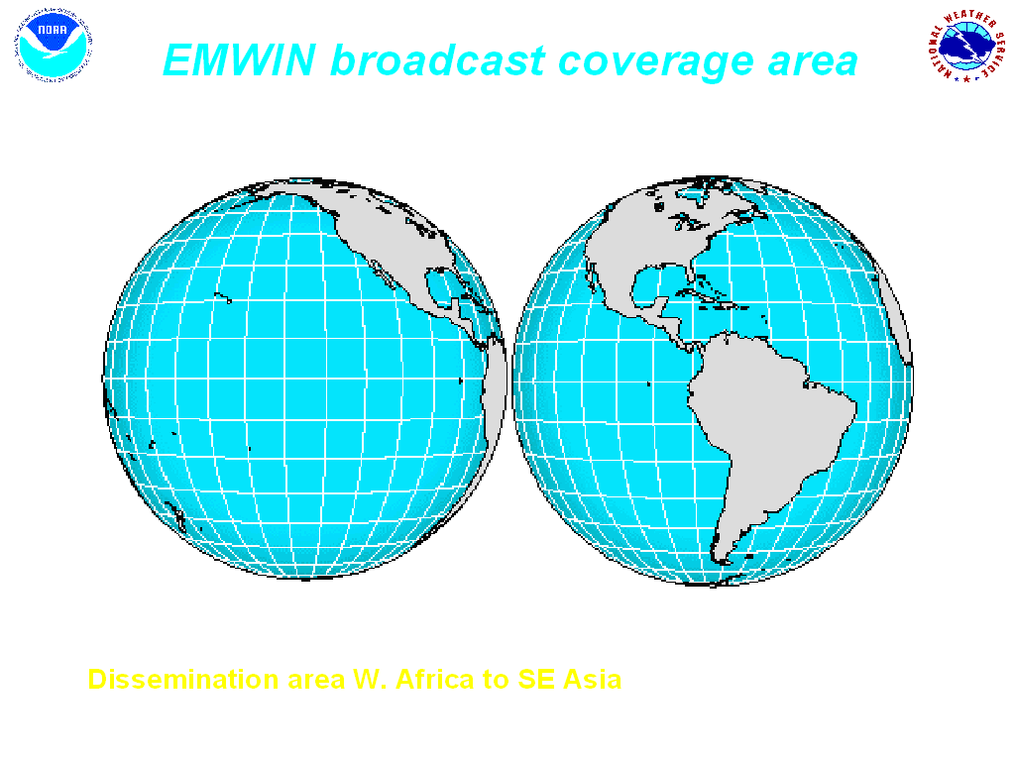
GOES Footprint FFOOTPRINT
GOES 10 (WEST)
GOES 12 (EAST)

Internet cloud
Standard Pentium PC
EMWIN SATELLITE Dish
Receiver
Internet access to Byte blaster network
Typical EMWIN Satellite User
Optional Alarm Controller

Data are collected from a variety of sources. The National Weather Service Telecommunications Gateway (NWSTG) is the primary data source but EMWIN will use our NOAA Weather Wire, Internet sources, and NESDIS sources to augment or replace the NWSTG data as necessary.

Data are assembled at the EMWIN servers and prioritized into high, medium, and low priority products. The products are sent in priority order on a 9.6kbs data stream to the GOES 10 and GOES 12 uplink master ground stations. At Pacific Region HQ, this data stream is received from GOES-10 and uplinked to PSAT to relay the signal further west. The entire bandwidth is always fully used. In the event that no products are queued at any given point in time, recent warning are resent.

EMWIN has a wide variety of users that include:
- National Weather Service Forecast Offices and Warning Coordination Meteorologists (WCM’s)
- Skywarn members, storm spotters and Local and National Emergency managers
- Canadian Met Service, South and Central American countries, Caribbean nations, Pacific Island nations, the NWS Pacific region.
- TV Stations in the mid-west U. S., especially tornado alley
- Police Stations, Fire Stations, Emergency Centers, Emergency response personnel
- Re-broadcasters, paging networks
- Worldwide Internet Users via Byte Blaster network
- U.S. Air force uses in remote areas

The Pacific region uses EMWIN for additional sources of Tsunami and Typhoon warnings. On some of the smaller islands, after a severe event there are times that the only weather system still functioning is EMWIN.

The equipment is inexpensive (as little as $1000 for a turnkey system). It requires almost no infrastructure. EMWIN runs on a laptop. A Solar powered version exists. The signal is “Weather Proof” due to L-Band transmission. The data-stream is free, repeatable and can be customized for retransmission. EMWIN is non-proprietary. Multiple inexpensive software display packages are available.

Specifications
- Frequency on GOES - 1690.725 MHz
- Modulation – Dual Frequency Shift Keying (DFSK)
- Speed - 9.6 kbps

Upcoming Changes:
- Power level of broadcast must be significantly reduced, therefore coding gains will be needed in order to keep current user dish size the same.
- Frequency and Modulation will change.
- This will probably result in additional bandwidth (19.2Kbps) design with focus on Pacific Region support.

ATTACHMENT-XII-IV: NWS eMail Data Input System (EDIS)

The NWS eMail Data Input System (EDIS) is a procedure that allows designated meteorological data providers the capability to input weather bulletins to the National Weather Service Telecommunication Gateway (NWSTG) - also known as the Regional Telecommunication Hub (RTH), via eMail.

This capability requires prior establishment of procedural controls.
(Go to EDIS Access Request Information)

NOTICE: This is an automatic process and every message submission will be disseminated world-wide as determined by the routing established for the WMO abbreviated heading you used. The submitting NMC or organization is responsible for the content of the bulletin(s).

Guidance for using EDIS
General Rules
- All input is ALPHANUMERIC ONLY in the current version.
- The WMO Bulletin - (See WMO Message Structure for Full Details)
  - The eMail information submitted is the WMO bulletin
  - The content of the WMO bulletin is:
    - An abbreviated heading line
      - T1T2A1A2ii CCCC YYGGgg [BBB]
    - Message text
- The email is submitted to the RTH via EDIS using a predefined eMail address.
EDIS Submission Rules and Definitions
- Messages must be sent in ASCII (plain text or alphanumeric code form).
- Two options are available for sending messages:
a. Messages may be sent as an attachment to the email (the attachment must have an extension .txt), or
b. Messages may be sent in the body of an eMail.
- The body of an email shall remain empty if attachments are used.
- One to five attachments are allowed per eMail.
- An attachment or body may contain one or more messages.
- The "subject line" shall contain: EDIS Message Input .
- The WMO abbreviated heading line and message text are the only required data for this email input form.
- The WMO abbreviated heading is entered in capital letters.
- The format of the WMO Abbreviated Heading Line is: T1T2A1A2ii CCCC [NNNXXX] YYGGgg (BBB) .
- The data time fields in the abbreviated heading must be current and meet the WMO standards of the Manual 386 Part II.
- The Pxx option of the BBB optional group is not allowed.
- The CCCC is the location identifier of origin of the "MESSAGE TEXT" being entered.
- The abbreviated heading T1T2A1A2ii CCCC must be previously defined at the RTH and will be validated against the NWS Switching Directory.
- No ASCII character control notations are required except for the report separator [ = ] signal.
- Each message must be ended with NNNN.
An Example of the Attachment or eMail Body:
SMMF01 TFFR 01000
AAXX 01124/
78890 36/// /0508 10244 20209 30120 40158 53016/ 333
10281 20228 58005=
NNNN

NTUS99 KNCF 031430
THIS IS A COMMUNICATIONS TEST MESSAGE ORGINATING FROM THE NMTR
SYSTEM IN SILVER SPRING IT IS SET TO TRANSMIT EVERY MINUTE
24 HOURS PER DAY, SEVEN DAYS PER WEEK
VIA A CRON JOB ON THE DS1-NMTR.ER SERVER.
NNNN
EDIS Access Request Information:
(please copy this information into your returning eMail)

EDIS Access Request Form
1. Name of NMC or sender: ____________________________________________
2. From eMail Address: _______________________________________________
3. Name of Contact(s): _______________________ ______________________
4. Phone number(s): _______________________ _______________________
5. Name of Shift Observer(s): ____________________ ____________________
6. Phone Number(s): _______________________ _______________________
7. Name of Chief Forecaster: __________________________________________
6. Phone Number(s): _______________________ _______________________

eMail this information to the Data Management Group
Please include the text " EDIS INPUT REQUEST " in the subject line of your eMail.
Note: Please copy and paste the information above into the body of your return eMail.
You will receive a return eMail containing the eMail address to use for sending the data within 3 working days of receipt.

To establish access to the EDIS, an email exchange between the TOC Data Management Group (DM) and the requesting data provider is required. The exchange of information establishes a valid ID necessary to gain access to the system. The data provider submits the meteorological data via email which consists of a standard WMO bulletin (i.e. the WMO abbreviated heading and text or body of the bulletin). The email is sent to a designated Gateway mailbox. The email is automatically processed and built into a file. The file is then placed into AFS for ingest by the WDE (see the Weather Data Exchange (WDE) System documentation). The WDE stores and routes the bulletin to the NWS switching system for distribution. All email messages must be sent in plain ASCII text format. Each message is ended with NNNN.

ATTACHMENT-XIII: METO Telecommunications Status Report (D. Hennings)

UK Met Office Telecommunications Status Report 2004

Prepared By:

David Hennings
Message Switching Team Tel: +44 (0)1392 884092
Met Office Fax: +44(0)1392-885681
Fitz roy Road e-mail:david.hennings@metoffice.com
Exeter, Devon
EX1 3PB, UK

1. Communication Links
Figure 1 UK Met Office Telecommunication links
Figure 1 shows some of the UK Met Office telecommunications links. The message switches FROST, TROPICS and NETlink send and receive data arriving over the links while the routers EXERT5 (and EXERT6) provide the connections to the circuits or managed network services.
The TROPICS message switch has mostly been replaced by the new FROST message switch .
The Regional Meteorological Data Communications Network (RMDCN) is a managed IP network service provided by Equant for the WMO National Meteorological Services (NMSs) in WMO region VI. RMDCN also supports X25 encapsulated in IP (XOT).
The Met Office has Frame Relay links with both British Telecom (Link to Australia BoM, and NOAA-OSO) and MCI Worldcom (Link to NOAA-NESDIS and CMC).

The following sections contain more detailed information on some of the links.

1.1 Links to NOAA
There are two links to NOAA, one to NOAA-NESDIS and a second to the NOAA Office of Systems Operations (NOAA-OSO).

1.2.1 Links to NOAA-OSO
The link to NOAA-OSO is a Frame relay line. There are two separate sockets data streams described in Table . The link utilisation is shown in Appendix A.

Protocol | NOAA-OSO System | Met Office | Data
TCP Sockets | NOAA-OSO Telecommunications Gateway | FROST | GTS
TCP Sockets | NOAA-OSO Telecommunications Gateway | FROST | T4 Fax Products
Table 1 Details of the links between METO and NOAA-OSO
(The leased line between Bracknell and Washington has now been replaced with a Frame Relay connection operating from Exeter.)

1.2.2 Links to NOAA-NESDIS
The Frame Relay link to NOAA-NESDIS is used for the transfers of satellite sounding data. Details on the link is shown in Table 2, the utilisation is shown in Appendix A and the daily volumes of data is shown in Table 4.

Speed Kbits/sec | Protocol | NOAA-NESDIS System | Met Office | Data
512 Access/ 128 CIR from NESDIS | FTP | CEMSCS | NETLINK | Satellite Sounding data and products, see Table 4
512 Access/32CIR to NESDIS | FTP | CEMSCS | NETLINK | ERS-2 Data
Table 2 Details of the links between Met Office and NOAA-NESDIS

1.2 Links to ECMWF
The 2MBits/Sec link to ECMWF is used to transmit files of data between Met Office and ECMWF using TCP/IP protocols. This data includes GTS Data, numerical modelling products and satellite data. Met Office users can also submit jobs to run on the ECMWF Supercomputer and access data on ECMWF computer systems using their MARS and METVIEW software.

1.3 Links to RMDCN
The link from Met Office to the RMDCN network has an access speed of 512 Kbits/S (ISDN backup 384Kbits/S). Permanent Virtual Circuits (PVCs) are established across RMDCN to other National Meteorological Services (NMSs) in WMO region VI. The details of some of the most used these are described in this section.

1.3.1 Links to Météo-France
PVC with a speed of 256Kbits/Sec out (Met Office to Météo-France) with agreed upgrade to 384Kbits/S, and 128Kbits/Sec in (Météo-France to Met Office).
The link is used for:
- Exchange of GTS and Radar data.
- Sending GOES and GMS satellite data to Lannion. This data is then sent from Lannion to METEOSAT for rebroadcast.
- Transmission of Met Office NIMROD products.
- Transmission of NOAA satellite sounding data such as the SSM/I and ATOVS data .
- Receipt of SAF OCEAN/ SST and ICE (planned) products. Poorman’s Ensemble data and NWP Precpitiation

1.3.2 Links to DWD
A PVC with a speed of 64Kbits/Sec in both directions has been established between the Met Office and DWD to exchange GTS products.

1.3.3 Other RMDCN Links
The MET OFFICE has the following PVCs through RMDCN to other NMSs

National Meteorological Service | Protocol | PVC Speed Kbits/Sec | Status
Belgium (Brussels) | FTP | 32 Both ways | Operational
Denmark | TCP Sockets | 32 Both ways | Operational
DWD | FTP | 64 Both ways | Operational
Iceland (Reykjavik) | FTP | 8 Both ways | Operational
Ireland (Dublin) | FTP | 64 Both ways | Operational
Italy (Rome) | FTP | 16 Both ways | Operational
Météo-France | FTP | 128 in  256 out [384*] | Operational
Russian Federation (Moscow) | FTP | 8 in/64 out* | Operational
Netherlands (De Bilt) | TCP Sockets | 64 Both ways | Operational
Norway (Oslo) | TCP Sockets | 32 Both ways | Operational
Portugal | FTP | 32 Both ways | Operational
Spain | TCP Sockets | 32 Both ways | Operational
Table 3 Details of RMDCN Links to other NMSs in WMO Region VI

United Kingdom
PVC to | CIR (kbps)  in | CIR (kbps)  out | NRT (ms)  specified | Service (%) availability
Belgium | 32 | 32 | 110 | 99.5
Denmark | 32 | 32 | 130 | 99.5
France | 128 | 256 | 170 | 99.5
Germany | 64 | 64 | 130 | 99.5
Iceland | 8 | 8 | 170 | 99.5
Ireland | 64 | 64 | 90 | 99.5
Italy | 16 | 16 | 130 | 99.5
Netherlands | 64 | 64 | 140 | 99.5
Norway | 32 | 32 | 130 | 99.5
Portugal | 32 | 32 | 220 | 99.5
Russian Federation | 8 | 64 | - | 99.5
Spain | 32 | 32 | 140 | 99.5
Table 4. Details of RMDCN Links from http://rmdcn.ecmwf.int/RMDCN.html

1.4 Other International Links
In an effort to gain routine, reliable access to global imagery from geostationary satellites, the Met Office has implemented links as described briefly below. The approach has generally sought to identify mutual benefit from the exchange of satellite data and, hence, sharing of the costs involved.

1.4.1 Australian Met. Service
A Frame Relay link has been established between the Met Office and the Australian Bureau of Meteorology (BoM) in Melbourne. The access speed is 256Kbits/Sec at each end and the CIR is 64Kbits/Sec in both directions. The link is being used for the exchange of data in WMO bulletin format using TCP sockets with FROST, files of satellite imagery (METEOSAT from UK and GMS from Australia) and ATOVS (HIRS) level 1D data with NETLINK.

1.4.2 Canadian Met. Service
A 32 Kbits/Sec Frame Relay link has been established between the Met. Office and the Canadian Met. Service (CMC) in Dorval. It is being used for the exchange of data in WMO bulletin format with FROST and files of satellite data (METEOSAT from UK and GOES from Canada) with NETLINK.

2. Met. Office Communication Computer Systems
There are two main computer systems at the Met Office that are used to send data to customers. The HP-UNIX-based FROST message switch sends WMO messages using FTP or TCP/IP sockets. FROST is planned to have some X25 Over TCP/IP capability later this year though most remaining X25 customers are encouraged to migrate to FTP or TCP sockets.

The TROPICS system, which is shortly to be retired, handles communications using direct X25 links and X25 over TCP/IP (including GTS traffic to CMC).

The NETLINK system exchanges files using FTP. In general FROST is used for the transfer of low volume data, typically from 100 Bytes to 50 Kbytes, where high speed data switching is important. NETLINK is used for the distribution of higher volume data at slower data switching speeds.

2.1 NETLINK
The NETLINK computer system is responsible for the operational transfer of files of data between computers on the Met. Office Central Data Network (CDN) and computers on external networks. It consists of two identical Compaq Alpha Computers running OpenVMS, the main node is called NETTLE and its backup is called TEAZLE.

Each NETLINK node is a HP Alpha 1200/533 with 256 Mbytes of memory running OpenVMS V7.3-1 operating system. Currently the system is switching 44,000 files per day, which is about 28 Gbytes of data.

Planning is in its early stages to replace the functionality of NETLINK with a new platform which integrates better with the new FROST system sometime in 2006.
In the mean time, to handle anticipated loading from Meteosat Second Generation (MSG) and some of the new satellite product sets, the nodes will be replaced by more powerful OpenVMS (HP Alpha) platforms.

Table 5 below, shows the data and its associated volumes sent to NETTLE over the Frame Relay link at present.

Requirements Description | Daily Data Volume (MBytes)
NOAA AMSU-A Level 1B | 92
NOAA AMSU-ABLevel 1B | 330
DSMP SSM/I Brightness temperatures | 220
NOAA TOVS MSU Level 1B | 1
NOAA TOVS SSU Level 1B | 13
QuikScat Scatterometer data | 209
NOAA AVHRR Products on a HIRS Grid. | 35
NOAA AVHRR 100km and 50Km SSTs | 7.9
NOAA AVHRR Mapped Global Area Composites | 6.3
NOAA Ozone Retrieved profiles and/or total column from SBUV | 1.2
AQUA AIRS Brightness temperatures | 300
AQUA AMSU-A Brightness temperatures | 11.5
NOAA TOVS HIRS Level 1B | 45.7
NOAA ATOVS HIRS Level 1B | 206.7
GOES cloud-tracked VIS/IR/WV Winds | 8.4
TOTAL | 1487.7

Table 5 Data Volumes from NESDIS to Met Office

Table 7 shows the anticipated increase in data volumes over the next year based on the data in the present European requirements list.

The expected increase in link capacity required to be able to accommodate that data is also shown.
The present link runs well below the frame relay access speed of 512Kb/s.
Currently the average is ~10% greater than the committed information rate (CIR) of 128 Kb/s, and will rise to +30% above CIR later this year with SSM/IS.
This speed could drop to the CIR if the supplier’s network becomes congested.
It has been previously proposed that the link is operated at a CIR similar to the average daily data rate with an access speed four times that value.

As long at the network continues to operate at the access speed there should be sufficient bandwidth and if the network becomes congested and the data rate drops we can pay to increase the CIR (up to 80% of the access speed).

At an earlier meeting of this Data Exchange group, a document containing options for backing up the data on the NESDIS link was prepared for discussion. The option selected was to routinely copy high priority data (defined as data crucial to operations) from the CEMSCS system at NESDIS to the NOAA-OSO FTP Server. In the event of a problem with the NESDIS link MET OFFICE would pull the data from this server over the NOAA-OSO GTS link and then pass it to the NETLINK system for processing.

The European Met Services provided information on the priority for the data sets on the dedicated link shown in Table . From the information provided it was decided to proceed with backing up the ATOVS level 1B data sets. Access to files on the NOAA-OSO server from Bracknell over the NOAA-OSO GTS link was successfully tested (in 2002). There is a requirement to reacquire the knowledge as to how this procedure works by Met Office staff working from Exeter.

Data Set | MET OFFICE | ECMWF | Météo-France
ATOVS Level 1b | 1 | 1 | 1
AVHRR 100/50 km SST | 3 | 4 | 3
AVHRR Mapped Images | 2 | 4 | 3
AVHRR products for HIRS | 3 | 3 | 3
GOES AMVs | 1 | 1 | 3
SSM/I Sea Ice | 4 | 1 | 4
TOVS Level 1B | 4 | 1 | 4
SBUV Ozone | 3 | 2 | 3
Quikscatt | 1 | 1 | 2
SSM/I BTs | 1 | 1 | 2
Table 6 Priorities for Data Sets on Exeter-NESDIS dedicated link

Categories are:
- High Priority (crucial for operations)
- Medium Priority (operational or pre-operational use but not critical
- Low Priority (research datasets)
- No Requirements

Date | Data Volume (Mbytes) | Average Link Speed (Kbits/Sec) | Link CIR (Kbits/Sec) | Link Access Speed (Kbits/Sec) | Additional Data Requirement
01/07/2000 | 650.0 | 61.6 | 64 | 256
01/10/2000 | 862.3 | 81.7 | 64 | 256 | NOAA-L
01/01/2001 | 862.3 | 81.7 | 64 | 256
01/04/2001 | 862.3 | 81.7 | 64 | 256
01/07/2001 | 1043.5 | 98.9 | 128 | 512 | Quickscatt NOAA-L AVHRR
01/10/2001 | 1073.5 | 101.8 | 128 | 512 | NOAA-L AVHRR
01/04/2002 | 1073.5 | 101.8 | 128 | 512
01/07/2002 | 1473.3 | 139.7 | 128 | 512 | NOAA-M AMSU & AVHRR
01/03/2004 | 1420 | 134.6 | 128 | 512 | AIRS and AMSU on AQUA
01/08/2004 | 1728 | 163.8 | 128 | 512 | SSM/IS,
Table 7. Data Volumes on the NESDIS Frame Relay Link.

2.2 FROST

The new Met Office FROST system is based upon a pair of HP L3000 servers running HP-UX Operating System software configured to run as a main system and a hot standby. There is a separate HP A500 Test & Development server.
A dedicated gigabit Ethernet link between the systems is used for management traffic and data synchronisation.
Application software is based upon the Messir-Comm message switching package for WMO message switching supporting FTP and TCP sockets. This is integrated with Nexor Mailer/Mixer software for general message switching using X.400 and SMTP. Legacy X.25 communications is supported by a pair of CISCO 3640 routers hot-switchable between servers. Operations and management of the system is performed using client software running on standard desktop PCs augmented by integration of the system with existing Met Office Tivoli and OpenView management platforms.
When migrating the Washington link from TROPICS to FROST, protocols were changed to use TCP sockets rather than X25.

The data volumes between Washington and Exeter are shown in Tables 4; 5 & 6 from the Frost Message Switch.

Date | Washington to Exeter |  | Exeter to Washington
 | Data (Mb) | Msgs | Data (Mb) | Msgs
April 1996 | 9.2 | 14256 | 9.1 | 13651
May 1997 | 9.6 | 15535 | 10.4 | 14662
May 1998 | 13.2 | 16524 | 11.0 | 15884
May 1999 | 17.5 | 18036 | 12.4 | 19199
June 2000 | 21.3 | 22123 | 14.2 | 24359
April 2001 | 32.7 | 23011 | 16.4 | 28925
June 2002 | 41 | 31354 | 18 | 32247
April 2003 | 35.6 | 28259 | 37.3 | 29612
May 2004 | 44.6 | 36961 | 17.1 | 29268
Table 8 GTS Link Alpha-Numeric Channel

Date | Washington to Exeter |  | Exeter to Washington
 | Data (Mb) | Msgs | Data (Mb) | Msgs
April 1996 | 72.8 | 19455 | 75.9 | 23463
May 1997 | 75.6 | 19220 | 77.3 | 23007
May 1998 | 80.1 | 19932 | 66.5 | 16259
May 1999 | 78.7 | 19876 | 68.7 | 16343
June 2000 | 83.1 | 20389 | 75.3 | 17763
April 2001 | 86.1 | 20740 | 86.6 | 20006
June 2002 | 163 | 36186 | 119 | 24961
April 2003 | 182 | 38834 | 130 | 27687
May 2004 | 181.4 | 40803 | 164.3 | 29302
Table 9 GTS Link GRIB Channel

Date | Washington to Exeter |  | Exeter to Washington
 | Data (Mb) | Msgs | Data (Mb) | Msgs
April 2001 | 5.4 | 59 | 5.4 | 60
June 2002 | 3 | 33 | 6 | 68
April 2003 | 3.3 | 33 | 7.5 | 74
May 2004 | 3.4 | 38 | 6.7 | 74
Table 10 GTS Link T4 Channel

The data volumes between Toulouse and Exeter are shown in Tables 7; 8 & 9 from the Frost Message Switch.

Date | Toulouse to Exeter |  | Exeter to Toulouse
 | Data (Mb) | Msgs | Data (Mb) | Msgs
May 2004 | 39.6 | 16785 | 71.3 | 47490
Table 11 GTS Link Alpha-Numeric Channel

Date | Toulouse to Exeter |  | Exeter to Toulouse
 | Data (Mb) | Msgs | Data (Mb) | Msgs
May 2004 | GRIB received on alpha channel |  | 98.2 | 27897
Table 12 GTS Link GRIB Channel

Date | Toulouse to Exeter |  | Toulouse to Toulouse
 | Data (Mb) | Msgs | Data (Mb) | Msgs
May 2004 | 18 | 1203 | 57.7 | 1476
Table 13 GTS Link T4 Channel

The data volumes between Washington and Bracknell are shown in Table7, Table8
& Table9.They show a large increase in GRIB data transferred, this is due to the addition of GRIB data exchange from model runs at 06Z and 18Z in the last year. The graph of link utilisation in Appendix A shows there are now daily four peaks which is the GRIB data exchange.

3 Met Office Relocation

The Met Office has moved to Exeter in the South West of the UK, around 170 miles from the previous location in Bracknell.
At the new site there are two separate IT Halls. Diversely routed communication ducts to each hall enable highly resilient communication circuits.
Migration of computer systems and circuits is complete with the present building in Bracknell having closed.

Appendix A. Utilisation of UK Met. Office Links to NOAA
Utilisation of UK Met. Office Links

Following are utilisation graphs for the following links:

- Washingtom – NOAA OSO
- RMDCN
- Dorval – CMC
- ECMWF

Note on the graphs which follow:
We are currently in the process of investigating new network monitoring tools, as the previous product has been dropped by the supplier. The following graphs have been captured from a basic OpenView monitoring package and as such are not ideal.

A1 Links to NOAA-OSO

A1.1 Utilisation of GTS Link from MET OFFICE from NOAA-OSO
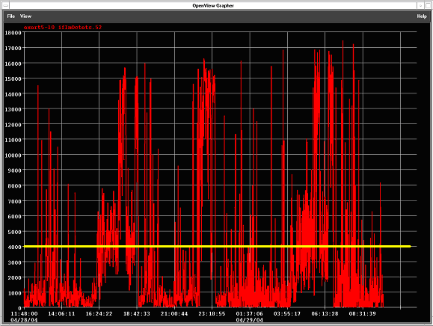
CIR marked as yellow horizontal line
A1.2 Utilisation of GTS Link from MET OFFICE to NOAA-OSO

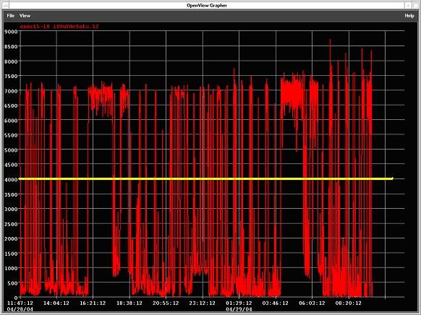

CIR marked as yellow horizontal line.

A2.1 Frame Relay Link to NOAA-NESDIS

CIR 128 Kbits/s (32K Octets) [Access: 512Kbits/s]
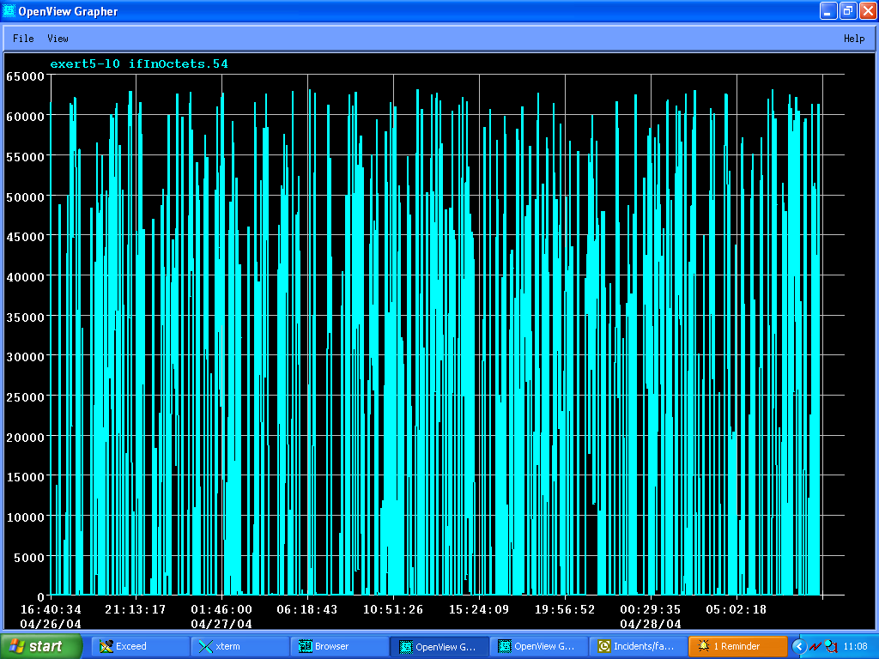

The graph shows the input utilisation of the Frame Relay link to NESDIS relative to a bandwidth of 512Kbits/Sec which is the access speed of the frame relay circuit in April 2004. The peak usage exceeds the CIR of 32K octets/sec by a factor of two.

A2.1 Frame Relay Link from NOAA-NESDIS

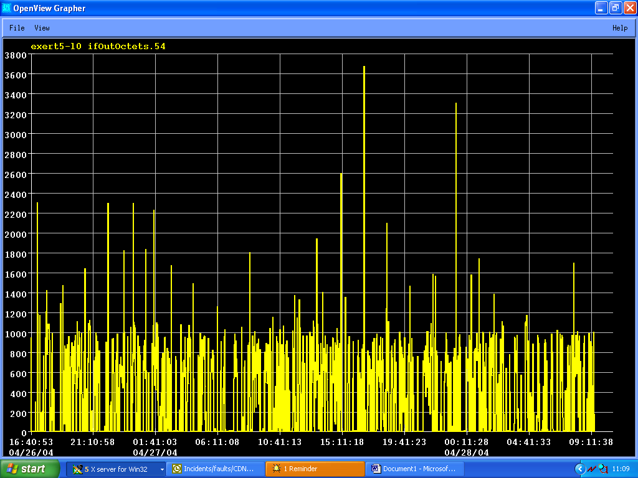

Well within the CIR of 32K octets/sec

A3 RMDCN

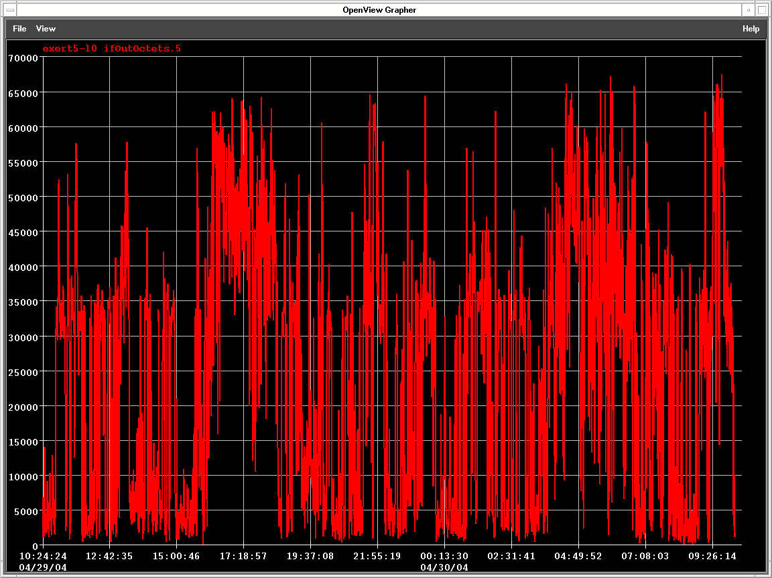

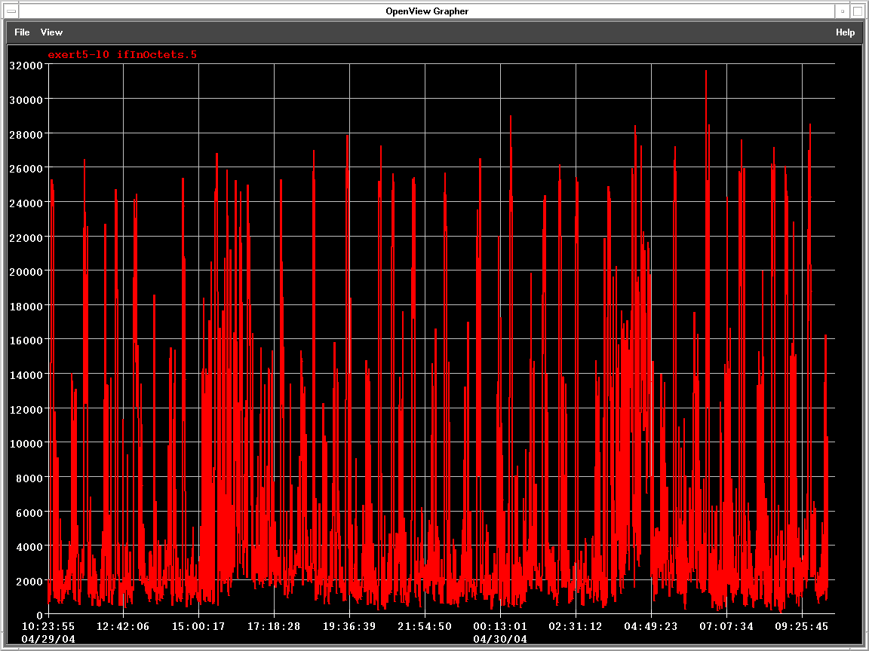
A4 Dorval CMC

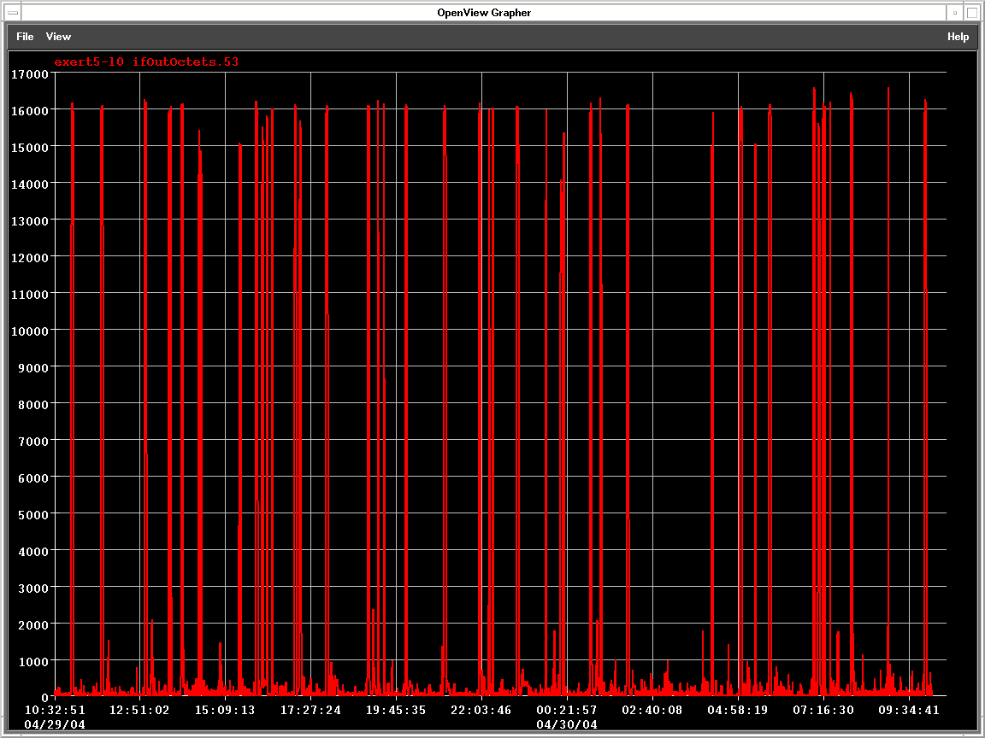

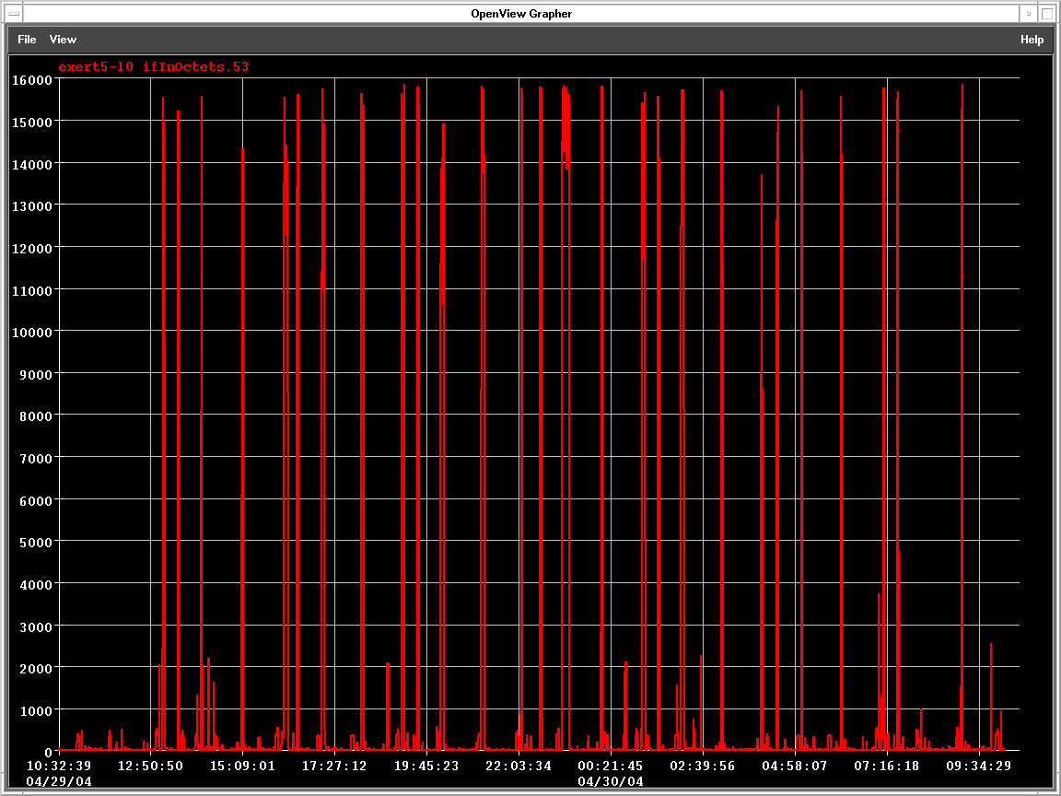
A5 ECMWF (Rx)

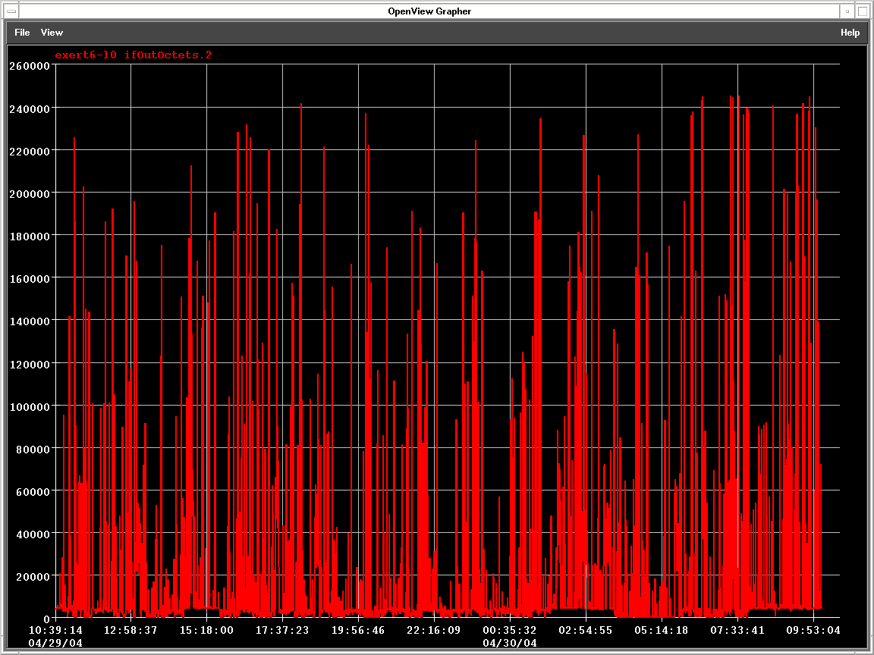

ATTACHMENT-XIV: Priorities on the Washington-Exeter link

Note: This item was not discussed at the meeting but is included for further reference.

